

Project and Professionalism

(6CS007)

Final Year Project

Survey Equipment Rental

Full Name : Mausham Dhakal

Student ID : 2358836

Group :L6CG19

Supervisor : Mr. Nikunja Lamsal

Reader : Mr. Shiv Kumar Yadav

Submission Date : 19th February 2025

Word Count :7858

**Abstract**

Surveying is a critical field supporting infrastructure development and land management in Nepal. However, the traditional methods of renting survey equipment remain highly inefficient, causing independent surveyors and small businesses to face challenges such as inconsistent availability, unclear pricing, and time-consuming manual coordination. To address these gaps, this project introduces Survey Equipment Rental, an online e-commerce platform designed to simplify and modernize the rental process. The platform allows users to browse categorized listings of equipment like total stations, GPS devices, and drones, check real-time availability, apply filters, and complete secure bookings through an intuitive web interface. It is built using React.js for the frontend, Node.js with Express.js for the backend, and MongoDB for database management. Key features include dynamic pricing, secure payment integration, user profiles, and real-time notifications. By creating Nepal’s first dedicated digital solution for survey equipment rental, the platform improves accessibility, transparency, and efficiency, offering a reliable tool for survey professionals and small businesses. Future expansions could include the ability to hire surveyors, offering survey equipment for purchase, launching a mobile application for broader access, and supporting cadastral surveying operations.

**Table of Contents**

**Introduction** 8

Project Briefing 9

Project Overall Working 9

Problem Domain 10

System as a Technical Solution 11

**Aims** 12

**Objectives** 12

**Artefact** 12

FDD (Functional Decomposition Diagram) 12

System as whole 13

Subsystems Descriptions 14

Academic Question 16

Explanation of Academic Questions 16

**Scope and Limitation of the Project** 17

Scope 17

Limitation 18

**Report Structure** 18

**Literature Review** 19

Paper 1 20

Paper 2 21

Paper 3 22

Paper 4 23

Paper 5 24

Paper 6 26

**Similar Related Work** 26

Asian Techno Traders 27

Office Materials System 27

Surveying Concern 28

Similarity Check 29

**Project Methodology** 29

Gantt Chart 31

Different Tools and Technology 31

**Artefact Designs** 34

Sub System Milestone 1 34

**SRS Document** 34

SRS for User Registration and Login (URL) 34

SRS for Equipment Search and Booking (ESB) 35

SRS for Payment and Notification (PNM) 35

SRS for Profile Management (PM) 36

SRS for Order Management (OM) 36

SRS for User Management (UM) 37

SRS for Admin Management (AM) 38

**Designs** 38

Entity Relationship Diagram 39

**Activity Diagram** 41

User Registration 41

User Login 42

Forget Password 42

**Sequence Diagram** 44

User Registration 44

Forgot Password 46

**Communication Diagram** 47

User Registration 47

User Login 48

Forgot Password 48

**User Management** 49

Use Case 49

Activity Diagram 49

Class Diagram 51

ER Diagram 51

Sequence Diagram 53

**Order Management** 54

Class Diagram 54

ER Diagram 55

Activity Diagram 56

Use Case Diagram 57

Sequence Diagram 58

**Activity Diagram** 59

User Confirms Order 59

User Extend Order 59

User Cancel Order 61

User Edit Order 62

Admin Accepts Order 63

Admin Cancel Order 64

**Product Management** 65

ER Diagram 65

Class Diagram 66

Activity Diagram 67

Use Case Diagram 68

Sequence Diagram 68

**Checkout Management** 69

ER Diagram 69

Class Diagram 70

Activity Diagram 71

Use Case Diagram 72

Sequence Diagram 72

**Notification Management** 73

ER Diagram 73

Class Diagram 74

Activity Diagram 75

Use Case Diagram 75

Sequence Diagram 76

**Wireframes** 76

**Testing** 76

Sub System 2 81

Sub System 3 81

Sub System 4 82

Sub System 5 82

**Conclusion** 82

Reflecting Aims and Objectives 83

**Critical Evaluation** 84

Final Report 84

Findings and Process 86

System Evaluation 87

Project Planning & Resources 88

Self-Reflection 90

**Evidence of Project Management** 91

Log Sheet 91

Gantt Chart 101

**References** 102

**Appendices** 103

**Table of Figures**

Figure 1:FDD Diagram 13

Figure 2: Index of different Artefacts 13

Figure 3:E-commerce Cycle. 23

Figure 4:E-commerce market in Nepal. 25

Figure 5: Application of E-commerce Case Study Challenges to Survey Equipment Rental and Corresponding Platform Strategies 25

Figure 6: Asian Techno Traders 27

Figure 7: Office Materials Nepal 28

Figure 8: Surveying Concern. 28

Figure 9: Scrum Methodology 30

Figure 10 : Major Milestone Gantt Chart 31

Figure 11: Subsystem Milestone 1 34

Figure 12 : ERD Diagram 39

Figure 13: Use Case Diagram 40

Figure 14 : Class Diagram 41

Figure 15: User Registration Activity Diagram 41

Figure 16: User Login Activity Diagram. 42

Figure 17: Activity Diagram of Forgot Password 43

Figure 18: Sequence Diagram of User Registration 44

Figure 19: Sequence Diagram of User Login. 45

Figure 20:Sequence Diagram of Forgot Password 46

Figure 21: User Registration Communication Diagram 47

Figure 22: User Login Communication Diagram 48

Figure 23: Forgot Password Communication Diagram 48

Figure 24: User Management Use Case 49

Figure 25: User Management Activity Diagram 50

Figure 26: User Management Class Diagram 51

Figure 27: User Management ER Diagram 52

Figure 28: User Management Sequence Diagram 53

Figure 29: Order Management Class Diagram 54

Figure 30: Order Management ER Diagram 55

Figure 31: Order Management Activity Diagram 56

Figure 32: Order Management Use Case Diagram 57

Figure 33: Order Management Sequence Diagram 58

Figure 34: Activity Diagram User Confirms Order 59

Figure 35: Activity Diagram User Extend Order 60

Figure 36: Activity Diagram of User Cancel Order 61

Figure 37: Activity Diagram User Edit Order 62

Figure 38:Activity Diagram Admin Accepts Order 63

Figure 39: Activity Diagram Admin Cancel Order 64

Figure 40: ER Diagram of Product Management 65

Figure 41: Class Diagram of Product Management. 66

Figure 42: Activity Diagram of product Management. 67

Figure 43: Use Case Diagram of Product Management. 68

Figure 44: Sequence Diagram of Product Management. 68

Figure 45 : ER Diagram of checkout Management. 69

Figure 46: Class Diagram of checkout Management. 70

Figure 47:Activity Diagram of checkout Management 71

Figure 48: Use Case Diagram of Checkout Management 72

Figure 49: Sequence Diagram of checkout Management. 72

Figure 50: ER Diagram of Notification Management. 73

Figure 51: Class Diagram of Notification Management. 74

Figure 52: Activity Diagram of Notification Management. 75

Figure 53: Use Case Diagram of Notification Management. 75

Figure 54: Sequence Diagram of Notification Management. 76

Figure 55: Login Testing 77

Figure 56: Testing of Invalid Login 78

Figure 57: User Registration Testing 78

Figure 58: Equipment Browsing Testing 79

Figure 59: Equipment Details Showing Testing 80

Figure 60 : Testing of Checkout Page 80

Figure 61: Logout Testing 81

Figure 62: Subs System Milestone 2 81

Figure 63: Sub System Milestone 3 81

Figure 64: Sub System Milestone 4 82

Figure 65: Sub System Milestone 5 82

Figure 66: How to easily write perfect literature review. 85

Figure 67: How to make activity diagram. 86

Figure 68: Understanding Scrum in depth. 89

Figure 69:React documentation 89

Figure 70: Log Sheet-1 91

Figure 71 : Log Sheet -2 92

Figure 72: LogSheet-3 93

Figure 73: Log Sheet-4 94

Figure 74: Log Sheet-5 95

Figure 75: Log Sheet-6 96

Figure 76: Log Sheet-7 97

Figure 77: Log Sheet-8 98

Figure 78: Log Sheet-9 99

Figure 79: Log Sheet-10 100

Figure 80:Gantt Chart 101

# **Introduction**

Nepal's fast-growing construction sector and surveying operations cause substantial increases in requirements for high-end surveying technology that includes total stations and drones together with GPS receivers level machines and digital theodolites. The increasing demand for survey equipment has led to major obstacles for independent surveyors and small businesses because of expensive equipment purchases along with shortage of equipment access combined with non-existent transparent rental solutions. Manual rental operations create operational inefficiencies and project cost increases through extended delays from unreliable availability and limited equipment supplier access along with multiple provider contacts and physical supplier visits due to pricing structure inconsistencies.

The "Survey Equipment Rental" project emerged as an answer to vital system limitations since it features a customized digital platform dedicated to improving survey equipment rental operations. The three key modern web technologies which power the platform include React.js for front-end development as well as Node.js with Express.js back-end development and MongoDB for database operations. These technologies ensure both scalability and high performance and great user experience. The Agile Scrum methodology facilitates system development through an iterative process which allows users to provide regular feedback for enhancing both platform usability and functionality.

Through this platform users gain access to a smooth rental experience which equips them with auto-updating equipment availability checks and secure online booking system and automated message alerts and full control over user profile management. The digital rental workflow of the platform solves classic rental failures while making pricing information clear and promoting dependable online transactions. The innovative service strives to enable survey professionals along with small businesses throughout Nepal through its efforts to deliver essential survey equipment which is easier to access, more affordable to obtain and better managed.

## Project Briefing

### Project Overall Working

The Survey Equipment Rental platform serves as an extensive e-commerce web application which enables the rental process of high-cost surveying equipment online. Since land surveyors and small businesses can rent essential surveying tools such as total stations, GPS devices and drones among others, the platform helps them access them without ownership while eliminating manual coordination requirements.

The platform operates with Admin and Customer as its main user types. Users have the capability to create an account and sign in before using the system to browse equipment while viewing information about details and adding desired items to the cart for secure payment. The system backend functions under admin control through management of user profiles as well as equipment entries booking history data and platform information. These administrators maintain complete authority to examine and change listings along with handling customer problems to manage system efficiency.

Real-time equipment availability together with dynamic pricing features stands alongside user profile management and secure payment integration as well as notification system functions and real-time equipment availability in this system. Users on this platform can register bookings via cart sections while the system handles customer surveys and stores booking logs.

The platform uses React.js for its frontend development because it creates a responsive interface for modern users simultaneously the backend relies on Node.js and Express.js to process application logic and routing needs. The MongoDB database delivers a storage solution which combines flexibility with scaling ability to store user details and booking records and product stock information. All project work follows the Agile Scrum model through which new features get created across multiple delivery periods called sprints. The system's evolution refined its performance through testing and feedback collection which happened during regular sprint planning and retrospective sessions. This enabled the system to deliver efficient solutions for practical needs.

### Problem Domain

The survey equipment rental system in Nepal has endured multiple difficulties since it became informal and created accessibility barriers. I struggle often to find suitable high-value equipment available for rent during fieldwork across my duties as an official land surveyor. Existing equipment rental procedures at Nepal operate as a fragmented manual system. The rental process requires phone and text message communication to various providers followed by physical visits to rental shops for correcting availability but there is no guarantee the tools will be available as needed.

A lack of unified rental listing platform produces various problems including unstable pricing along with equipment shortages and complicated scheduling and insufficient information disclosure. Small organizations and independent surveyors suffer more because they have limited resources to buy equipment alongside substantial delays to find available rentals. The lack of adequate equipment verification processes causes users to be at risk because providers demand advance payments before confirming equipment condition.

The current reality indicates that Nepal lacks any official or structured online marketplace which focuses on survey equipment rentals. All operations currently function offline and solely rest on the resources of personal contacts and antiquated methods. Without digitization the rental market has become challenging to manage and the processes need improvement for better reliability and efficiency. Surveyors require a modernized rental solution which should be both accessible and trustworthy at scale for the surveying industry to address current inefficiencies in the market.

### System as a Technical Solution

This enterprise solves Nepal’s survey equipment rental sector deficiencies by building a complete digital platform for equipment rental management. The scheduling system offers instant bookings through a structured listing system that lets users view possible availability and choose length of rental time along with cost displays with adjustable pricing based on market demand to complete easy equipment reservations.

The platform resolves manual coordination issues by using automated booking confirmation processes as well as live inventory management. Through dynamic listing management providers can remove equipment availability doubts from their operations. The site builds client trust through comprehensive product pages that display descriptions together with images featuring user-generated feedback systems.

The solution focused on security needs to match its ability to scale up. The system provides secure user authentication followed by role-based access control and contains payment processing features. The system provides notifications to users which update them regarding booking confirmations together with equipment returns and resolution of occurring issues. The platform possesses scalability through its foundation of the frontend technology React.js along with Express.js and Node.js on the backend and MongoDB for database usage enabling growth for additional users and equipment varieties while extending into new geographic regions.

## **Aims**

* To design and develop a user-friendly digital platform that improves access to professional survey equipment through a centralized rental system.
* To enhance efficiency and transparency in the survey equipment rental process by replacing traditional, manual methods with a modern e-commerce solution.
* To support the long-term scalability and digital transformation of the equipment rental industry in Nepal, especially for small businesses and independent surveyors.

## **Objectives**

* To solve the problem of limited and inconvenient access to survey equipment by providing a platform where users can easily browse, filter, and rent tools based on their specific project requirements.
* To address concerns related to trust and security in online rentals by implementing secure user authentication, payment systems, and transparent booking processes.
* To overcome static and inflexible pricing models by introducing dynamic pricing that adjusts based on demand, availability, and seasonal trends, improving affordability and utilization.

## **Artefact**

### FDD (Functional Decomposition Diagram)

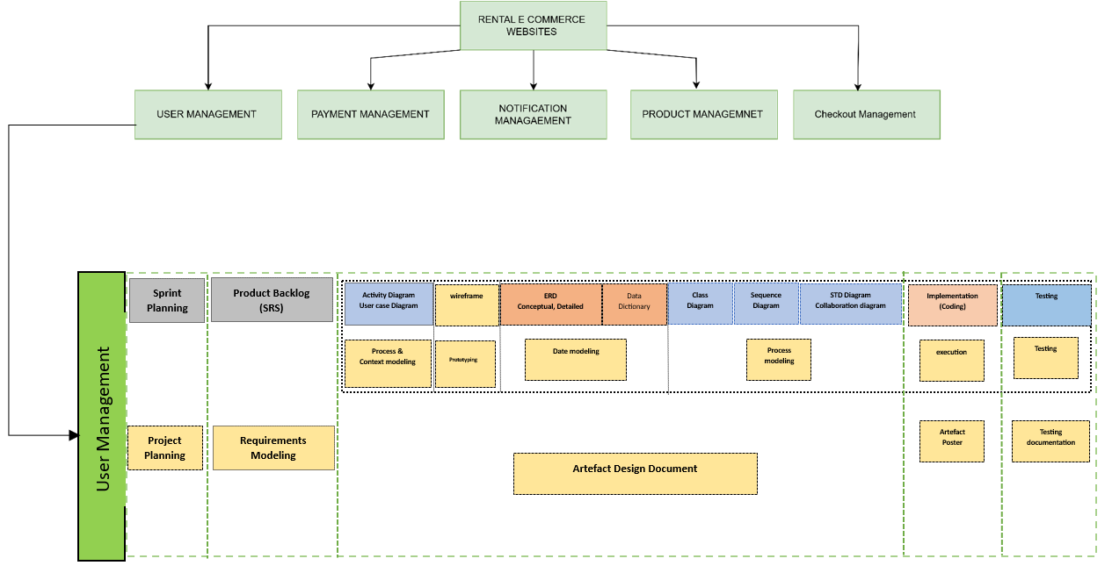

Figure 1:FDD Diagram

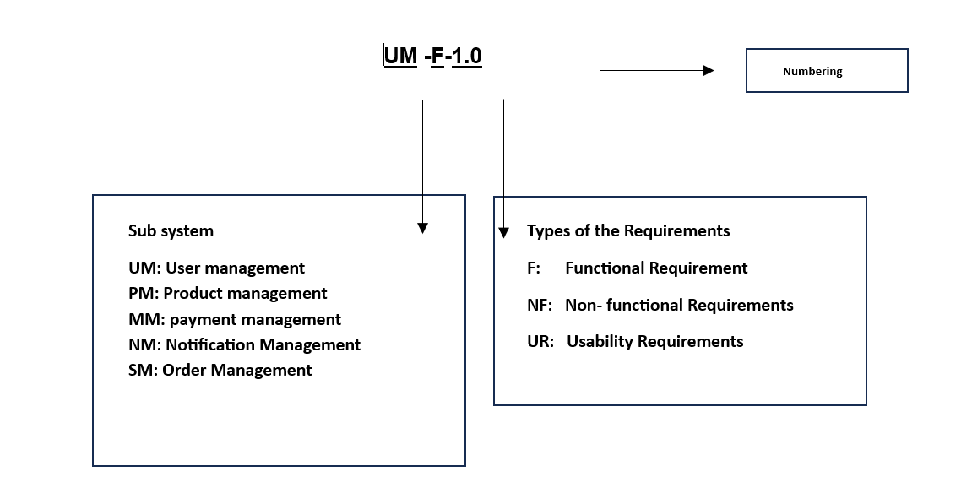

Figure 2: Index of different Artefacts

### System as whole

The Survey Equipment Rental system starts with a Registration and Login where users can create a new account or log into the platform. After logging in, users can view and update their profiles, as well as manage their rental bookings. The Equipment Management allows users to browse different types of survey equipment such as total stations, drones, and GPS receivers, and filter them based on availability and category. Users can view real-time availability and select equipment according to their needs. Booking Management (BM) handles the rental process. Users can add equipment to their booking cart, select rental durations, and complete secure payments. After booking, users receive notifications and updates regarding their rental status. The system supports different payment methods and ensures secure transactions during the booking process.

Admin Management allows the admin to add new equipment, update equipment details, manage rental availability, and monitor overall user activities and transactions. Notifications are automatically sent to users when bookings are confirmed or updated. In addition to these core features, the platform includes static pages such as the Home Page, About Us page, and Contact Us page. The Home Page introduces the platform and highlights available equipment. The About Us page shares the project’s vision and purpose. The Contact Us page allows users to reach out for help or inquiries.

Overall, the system provides a smooth and secure rental experience for surveyors and small businesses in Nepal, improving accessibility, transparency, and efficiency compared to the traditional manual rental process.

### Subsystems Descriptions

**User Registration and Login**

Allows users to create an account, log in securely, and manage their session. Upon registration, users can access full platform features, view their profile, rental history, and saved preferences.

**View and Update Profile**

Enables users to update personal information such as contact details, password, and payment methods. It also displays the user’s rental history and preferred equipment.

**Browse and Filter Survey Equipment**

Provides a searchable and filterable catalog of equipment, including total stations, drones, GPS devices, theodolites, and levels. Users can filter results based on availability, price range, and category.

**Book Equipment**

Users can select equipment, define the rental duration, choose delivery/pickup options, and confirm payment. Real-time availability and cost calculation are displayed before final booking.

**Dynamic Pricing System**

Implements variable pricing based on factors like equipment demand, seasonality, and inventory availability. This helps optimize resource utilization and encourage rentals during off-peak times.

**Add to Cart**

Allows users to add multiple equipment items into a cart and review them before completing a rental transaction. This makes multi-item bookings seamless and efficient.

**Notification System**

Generates automated notifications to users and administrators regarding booking confirmations, rental status updates, due returns, and any critical system alerts.

**Customer Reviews and Ratings**

Implementing a feedback and rating system would allow users to review equipment and share their rental experience. This not only builds trust within the platform but also assists future users in making informed rental decisions based on previous feedback.

**Discounts and Loyalty Program**

To promote customer retention, a loyalty program could be introduced, offering discounts or reward points to frequent users. This initiative would encourage repeat business and foster long-term relationships with users.

## Academic Question

* How can an e-commerce platform simplify survey equipment rentals for better customer retention?
* How can accessibility and efficiency in survey equipment rentals be improved through e-commerce?
* How can an e-commerce platform optimize costs and support growth for small survey businesses?

### Explanation of Academic Questions

**1.** How can an e-commerce platform simplify survey equipment rentals for better customer retention?

Traditional survey equipment rental processes in Nepal are time-consuming, inconsistent, and often based on informal networks. By digitizing this process, the project investigates whether an intuitive, centralized platform can make renting easier and more reliable. Simplification is expected to improve the user experience, which in turn may encourage repeat usage and increase customer retention. Features such as real-time availability, clear pricing, and easy booking aim to address this question.

**2.** How can accessibility and efficiency in survey equipment rentals be improved through e-commerce?

Many independent surveyors and small businesses face barriers due to limited access to equipment and inefficient rental procedures. This project explores how e-commerce can offer 24/7 accessibility, streamlined logistics, and reduced manual effort. By implementing online filtering, booking, and notifications, the platform aims to significantly improve the efficiency of equipment rentals compared to traditional methods.

**3** How can an e-commerce platform optimize costs and support growth for small survey businesses?

High upfront costs for equipment ownership can hinder growth for smaller survey businesses. This question examines how a rental-based e-commerce model can reduce these financial burdens through flexible, on-demand access. Moreover, the integration of a dynamic pricing system allows the platform to adjust costs based on demand and seasonality, offering a financially viable alternative for long-term sustainability and scalability.

## **Scope and Limitation of the Project**

### Scope

The scope of the project is to develop a full-stack e-commerce web application tailored to the rental of survey equipment in Nepal. The platform specifically targets independent surveyors and small businesses who face challenges in accessing expensive tools due to high costs, limited availability, and a lack of centralized rental system. The platform provides a user-friendly way to search, filter, book, and manage equipment rentals securely and efficiently.

The system offers the following key functionalities:

* **User Management**: Registration, login, and profile management including personal information, rental history, and preferences.
* **Product Management**: Admin-side interface for adding, editing, and managing survey equipment listings including categories such as total stations, GPS devices, drones, and theodolites.
* **Browse and Filter**: Customers can search and filter available equipment based on type, price, and availability.
* **Booking and Rental Workflow**: Equipment booking with customizable rental duration, delivery/pickup preferences, and live rental cost calculation.
* **Add to Cart**: Users can manage multiple equipment selections before completing checkout, enabling batch rentals.
* **Dynamic Pricing System**: Pricing is adjusted based on factors such as demand, seasonality, and equipment availability.
* **Secure Payment Integration**: Basic online payment processing for secure transaction handling.
* **Notification System**: Automatic alerts for booking confirmations, equipment availability, and rental reminders.

The platform is built using React.js for the frontend, Node.js with Express.js for the backend, and MongoDB for data management. Developed using the Agile Scrum methodology, the system is scalable and designed for future growth, with potential to expand into additional surveying services or broader rental categories.

### Limitation

While the Survey Equipment Rental platform successfully achieves its main objectives, there are certain limitations in the current version due to time, technical, and resource constraints. Some additional features and improvements have been identified for future development.

* **Real-Time Equipment Tracking**: The system does not yet support GPS or RFID-based tracking of rented equipment due to hardware and infrastructure limitations.
* **Loyalty and Discount Programs**: Features like customer rewards or loyalty discounts are not available in the current version and are planned for future upgrades.
* **Advanced Payment Options**: Although basic payment is supported, the system does not currently offer mobile banking, installment payment plans.
* **Logistics and Delivery Tracking**: Users can input delivery preferences, but live delivery tracking or third-party logistics integration is not currently part of the system.
* **Mobile Application**: The platform is developed for web access only no Android/iOS application is available in the current release.
* **High-Load Performance Testing**: Due to infrastructure limitations, the platform was not tested under large-scale concurrent user conditions in a real-world environment.
* **Multilingual Interface**: The application supports English only; regional language support was not implemented in this phase.

These limitations serve as opportunities for future enhancement based on user feedback, market demand, and the potential growth of the platform.

# **Report Structure**

1. **Introduction**

This section provides an overview of the project and its objectives, addressing key elements:

* Project Title
* Problem Domain
* Project as a Solution
* Aims and Objectives
* Artefact Overview
* Academic Questions
* Scope and Limitation

1. **Research Works**

This section outlines the research background and supports the need for this system:

* Literature Review
* Review of Similar Systems

1. **Project Methodology**

This section details the methodology followed during development:

* Scrum Methodology
* Tools and Techniques Used
* Gantt Chart
* Artefact Designs and Diagrams

1. **Conclusion**

This section presents final thoughts and evaluation of the system:

* Self-Reflection
* Critical Evaluation
* Evidence of Project Management

# **Literature Review**

When evaluating whether to rent or purchase equipment, organizations must weigh a range of financial factors including upfront capital investment, ongoing maintenance costs, depreciation, and asset flexibility. Studies analyzing this dilemma often conclude that renting is a more suitable option for businesses that do not require constant access to specific tools, as it helps conserve capital, avoid long-term maintenance responsibilities, and reduce storage burdens. On the other hand, ownership can be more cost-effective for businesses with high equipment utilization over extended periods.

In the context of the surveying industry, especially in developing regions like Nepal, these findings become particularly relevant. Equipment such as total stations, GPS receivers, drones, and digital levels are highly specialized and expensive. For independent surveyors or small firms with limited budgets, owning such tools can be financially impractical especially when they are only needed occasionally or for short-term projects. Purchasing these items outright not only demands a large initial investment but also introduces recurring expenses related to calibration, servicing, insurance, and safe storage.

By contrast, a rental-based approach offers survey professionals the flexibility to access equipment on demand, tailored to each project’s specific requirements. This eliminates unnecessary overheads and allows firms to respond more dynamically to varied client needs. The cost savings realized through renting are especially beneficial when working on projects that require a mix of tools, each for a limited duration. Ultimately, applying the rental model to survey equipment makes operational and economic sense — reducing financial risk while increasing access to high-quality tools that might otherwise remain out of reach for many in the industry. (Bajwa, 2021) (Padmanaban G, 9 Jan 2025)

## Paper 1

“Logistic and Operational Challenges”

Efficient logistics play a crucial role in the success of any rental-based business, and survey equipment rental is no exception. While many existing studies discuss logistics in the context of electric vehicle (EV) operations and fleet management, several of the highlighted challenges directly overlap with those encountered in the rental and transportation of surveying instruments. These include the timely movement of equipment across varying locations, the coordination of pickup and return schedules, and the maintenance of bulky or sensitive tools like total stations, drones, and GPS units.

For survey equipment rentals, ensuring that devices are delivered to project sites on time is critical. Surveyors often work on strict timelines, and a delay in receiving the necessary equipment can cause serious project disruptions. Planning optimal routes for delivery and return, as well as having backup logistics in place, is essential to minimize downtime. Furthermore, just as EV infrastructure requires charging and maintenance stations, survey instruments demand periodic calibration, inspection, and secure storage between rentals. These operational needs add complexity and cost to the business model but are vital to maintaining service quality and reliability.

Another logistical factor is real-time tracking. For both EVs and rental equipment, knowing the exact location of items in transit or during active use ensures better planning and accountability. In the case of survey equipment, it also helps avoid misplacement and ensures timely retrieval for reallocation. By incorporating efficient routing, maintenance planning, and location tracking into the platform, the system can address the unique logistical pressures of survey equipment rental while delivering a more seamless and dependable experience for users. (Angel Alejandro Juan, 28 January 2016) (Grigorios D. Konstantakopoulos, July 2022) (Ankita Chawla, 20 April 2021 )

## Paper 2

“Ecommerce in Rental Business”

The evolution of e-commerce has significantly influenced how rental businesses operate, offering a framework that simplifies transactions, enhances accessibility, and reduces the need for physical interaction. Literature on e-commerce models emphasizes how digital platforms improve user convenience by enabling remote browsing, real-time bookings, and secure online payments. These principles align well with the nature of the survey equipment rental market, where tools are typically expensive, highly specialized, and needed for short durations by professionals working on project-specific assignments.

Surveyors often face the challenge of locating the right equipment at the right time a process that can be inefficient when handled through traditional phone calls or in-person visits. E-commerce systems solve this by offering an intuitive web interface where users can filter tools based on availability, category, and pricing, and instantly reserve them for a selected time window. This eliminates guesswork and reduces delays in project execution.

The importance of robust inventory management is also highlighted in the literature. In the survey rental context, real-time stock tracking prevents double bookings, ensures accurate availability updates, and minimizes customer frustration caused by late returns or unreturned equipment. The inclusion of dynamic pricing mechanisms, as discussed in the papers, allows the platform to adjust rental costs based on demand and usage patterns, giving surveyors the flexibility to choose tools that match both their project needs and budget.

Moreover, the integration of customer analytics can support smarter recommendations — suggesting equipment based on rental history or project type. When applied effectively, these e-commerce strategies not only streamline operations but also boost customer satisfaction, resource efficiency, and overall platform reliability in the survey equipment rental industry. (Chukurna, 2024) (Anuj Pal Kapoor, May 2021)

## Paper 3

“Rental platform Security and Trust Mechanism”

With the rapid growth of e-commerce platforms, ensuring the security of digital transactions has become a core concern, particularly for systems that handle high-value items and sensitive user data. Literature on e-commerce security outlines how online platforms face various risks across the transaction cycle — from browsing and selection to payment and post-rental communication. Threats such as data breaches, unauthorized access, denial-of-service attacks, and fraudulent activities pose serious risks to both the business and its customers, potentially undermining user trust and the platform’s credibility.

In the context of survey equipment rental, these concerns are especially relevant. Customers entrust the platform with personal information, payment details, and high-cost rental agreements. To maintain trust and safeguard transactions, the system must implement modern security protocols such as SSL encryption, digital certificates, and secure authentication processes. These measures ensure that data remains confidential, transactions are verified, and access is restricted to authorized users only.

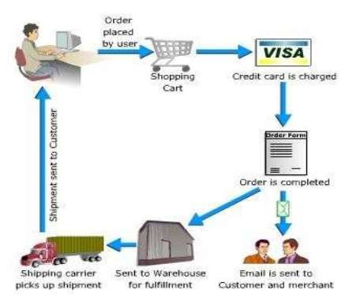

Figure 3:E-commerce Cycle.

The literature also highlights advanced protections like role-based access control, audit logging, and digital signatures, which are vital in tracking activity and preventing repudiation of actions. These are particularly important when disputes arise or when verifying equipment bookings and payments. The dynamic nature of online threats also calls for regular security reviews, user awareness initiatives, and adherence to best practices all of which contribute to a stable and trustworthy rental environment.

By adopting these strategies, the survey equipment rental platform not only protects its infrastructure but also builds user confidence. A secure and transparent system becomes essential in encouraging repeat usage, minimizing transaction-related fears, and promoting the overall success of the rental ecosystem in a digital space. (Liwei Li, 2020) (Mitchell Watt, August 2018)

## Paper 4

“Customer Behavior and Preferences in Rental Services”

Consumer behavior in the rental market has evolved rapidly, particularly following the pandemic, where safety, speed, and convenience became top priorities. Research into recent trends shows that customers now expect seamless digital experiences, with minimal physical contact and fast service delivery a shift that directly applies to the survey equipment rental industry as well. Surveyors and professionals, like many modern consumers, increasingly prefer platforms that offer touchless bookings, real-time confirmations, and secure digital payments, avoiding the delays and uncertainties often tied to traditional rental methods.

The concept of contactless service, widely adopted in retail, can also be adapted to survey rentals by enabling digital agreements, flexible pickup/drop-off options, and automated payment systems. This not only improves user experience but also builds confidence in the platform’s professionalism and responsiveness.

The literature also emphasizes the importance of real-time customer feedback and the role it plays in shaping business decisions. For a rental platform, actively monitoring user reviews, social media sentiments, and support queries can reveal preferences that inform stock management, promotional campaigns, and pricing models. For example, understanding which equipment types are most requested during specific seasons or which rental durations are most common can guide more targeted offerings.

Moreover, the ability to adapt quickly to shifting customer expectations is crucial. Offering dynamic pricing, personalized recommendations, or limited-time discounts based on user history can make the rental experience feel tailored and responsive. In the competitive rental space, these strategies not only drive customer satisfaction but also encourage repeat usage, making them essential tools for sustaining long-term engagement in the survey equipment rental market. (Stacy H.N. Lee, 2020) (Santhoskumar A, April 2024 )

## Paper 5

“Case Studies and Market Demand”

Through the review of case studies and market insights from the broader e-commerce sector, several key lessons emerge that are directly relevant to the development and sustainability of a survey equipment rental platform. One major challenge highlighted in the literature is the lack of strong digital marketing strategies, which can lead to weak brand recognition and difficulty in acquiring or retaining customers. This issue is particularly pressing for niche platforms like survey equipment rental, where the target audience such as small construction firms, independent surveyors, and contractors may not be actively looking for rental services online unless visibility is created.

Addressing this gap requires the strategic use of digital channels, including social media, search engine optimization, and targeted ad campaigns, to increase platform awareness. Effective online outreach can help bring the service in front of the right users, especially in a market that is still transitioning from traditional rental practices to digital solutions. Security also remains a critical concern. Renting high-value tools online involves both financial transactions and sensitive user data. The papers reviewed stress the importance of secure payment systems, encryption protocols, and multi-factor authentication (MFA). By implementing these mechanisms, the platform can protect its users and establish a trustworthy reputation, which is essential in fostering repeat usage and long-term customer loyalty.

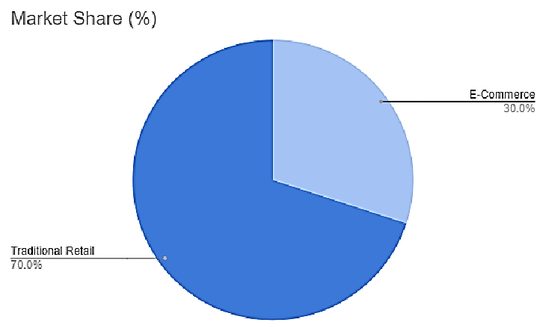

Figure 4:E-commerce market in Nepal.

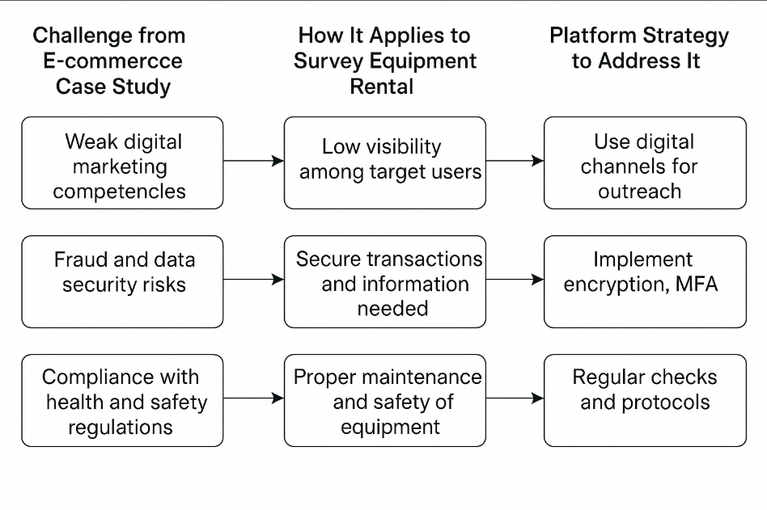

Figure 5: Application of E-commerce Case Study Challenges to Survey Equipment Rental and Corresponding Platform Strategies

Additionally, survey equipment must adhere to proper maintenance and safety standards. Regular checks, cleanliness protocols, and clear usage guidelines ensure customer satisfaction while maintaining platform credibility. Delays or equipment failures due to poor logistics or neglect can severely damage user trust. Hence, applying best practices from established e-commerce platforms can guide both operational and marketing improvements in this domain. (Nandi, 2025) (Anton Jansson, 22)

## Paper 6

“Sustainability and Environment Impact of Equipment Rentals”

Although much of the literature on sustainability in rentals focuses on industries like fashion, many of the principles translate well into the context of survey equipment rental. One key concept is the importance of cleanliness and safety protocols. Just as rented clothing undergoes cleaning and inspection before reuse, survey tools such as total stations, drones, and GPS devices must be carefully maintained between rentals. This not only extends the functional lifespan of expensive equipment but also assures users that the tools they are receiving are safe, reliable, and professionally managed.

Another parallel lies in communication and transparency. In fashion rentals, customers are often guided by clear rental terms, care instructions, and return policies. A similar level of clarity should be embedded into survey equipment rental platforms. Clearly defining rental durations, usage guidelines, safety instructions, and damage protocols helps establish trust while reducing misuse. These efforts also support smoother operations and reduce unnecessary wear or accidental loss.

However, this is not only about the physical product it extends to the platform’s social and economic impact. While fashion brands may focus on ethical labor or recycling, survey rental platforms can promote inclusive access by serving small firms, individual surveyors, and academic institutions that may not afford high-end tools outright. Enabling shared access to quality equipment fosters resource efficiency and promotes a more equitable industry landscape.

By applying these sustainability practices, the survey equipment rental model not only minimizes environmental waste but also strengthens customer loyalty and contributes to the responsible growth of the sector. (Lindsay McCoy, 2022), (Costamagna, 2023)

# **Similar Related Work**

## Asian Techno Traders

Asian Techno Traders Pvt. Ltd. is one premier suppliers of survey equipment rentals in the market in Nepal. Total Stations, Auto Levels as well as other surveying equipment; available from the website has undergone various tests by experienced technicians. The full inventory of the bikes and the details about renting -inventory, pricing and availability, and other features of the bikes are available to users registered on the site. It also has background information about the industry and current developments. Qualified workers help to choose a suitable tool to the customer. (Basnet, n.d.)

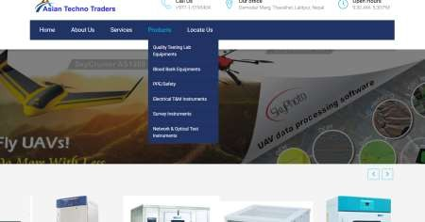

Figure 6: Asian Techno Traders

## Office Materials System

Office Materials System offers wide range of surveying and construction instruments for sale which include; Total Stations, Digital Theodolites, and Leveling Machines. It is a reliable supplier of surveying and measuring instruments that serves the requirements of various professionals of Nepal. It deals with supplying quality products for several sectors such as construction and surveying. But they appear not to provide rental service for these products. (System, n.d.)

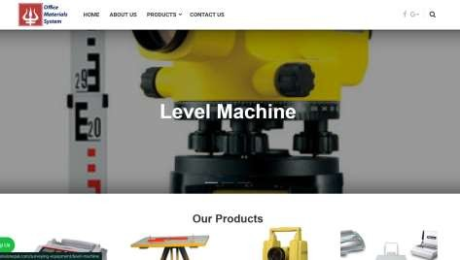

Figure 7: Office Materials Nepal

## Surveying Concern

Surveying Concern offers surveying instruments like Total Stations, GPS and Digital Theodolites primarily selling its own products. They supply surveying equipment to surveyors and civil engineers in Nepal, but they don’t have the retail service for internet shopping or equipment rental. Unlike most online based companies, their main focus involves coming into direct contact with the consumers. (Creation, n.d.)

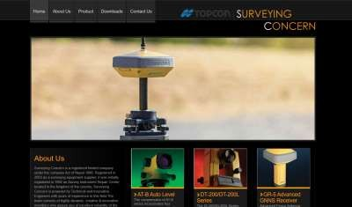

Figure 8: Surveying Concern.

## Similarity Check

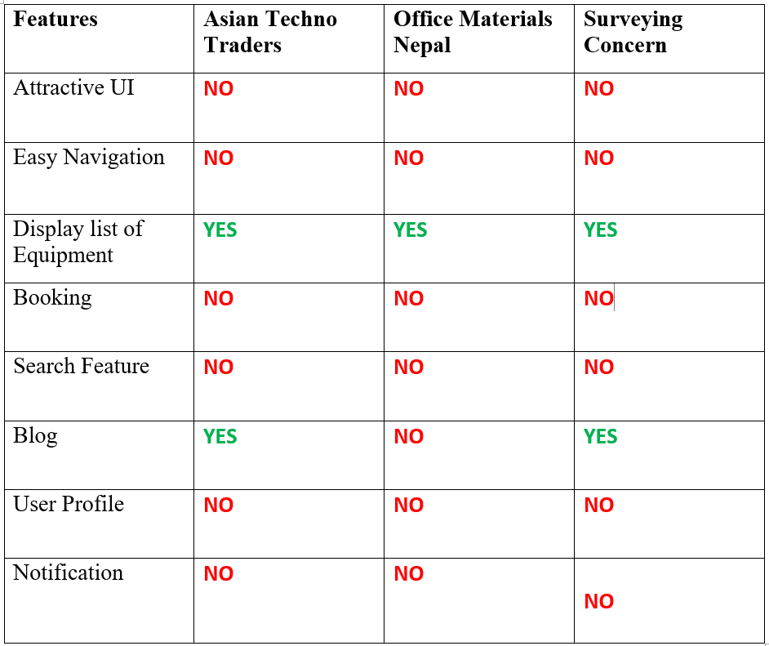

Table 1: Similarity checklist

# **Project Methodology**

Scrum was selected as the development methodology due to its flexibility, adaptability, and its strong alignment with the modular and user-driven nature of the Survey Equipment Rental Platform. The system required constant improvement, evolving requirements, and frequent feedback all of which are best supported by Scrum.

Scrum was chosen to suit the specific needs of the Survey Equipment Rental Platform, allowing flexibility, incremental delivery, and continuous user feedback throughout development. (S, 2025)

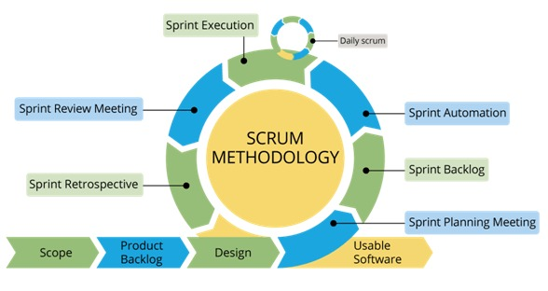

Figure 9: Scrum Methodology

**Iterative Development for Modular Subsystems**

The system was divided into smaller functional modules — such as user authentication, product listing, booking and checkout, payment processing, and notifications. Scrum enabled each module to be developed, tested, and improved incrementally during sprints, reducing complexity and allowing better focus on quality.

**Flexibility to Accommodate Change**

During development, certain features like dynamic pricing, cart management, and notification logic needed to be adjusted based on feedback. Scrum provided the flexibility to revise plans and priorities sprint-by-sprint without disrupting the overall flow of the project.

**User-Centric Design**

The target user surveyors and small rental businesses had specific needs. Scrum’s frequent review cycles made it easier to validate that each sprint aligned with user expectations and real-world use cases. This helped build a more relevant and usable product.

**Incremental Feature Delivery and Early Testing**

Scrum enabled early development of core features, which were tested and validated before additional complexity was added. For example, equipment browsing and cart functionality were completed early, tested, and improved before implementing advanced features like payment and feedback systems

**Enhanced Project Visibility and Control**

Each sprint allowed for planning, task breakdown, and review. Using tools like ClickUp made it easier to manage tasks and deadlines. This level of visibility and control helped prevent bottlenecks and ensured smooth project progression.

## Gantt Chart

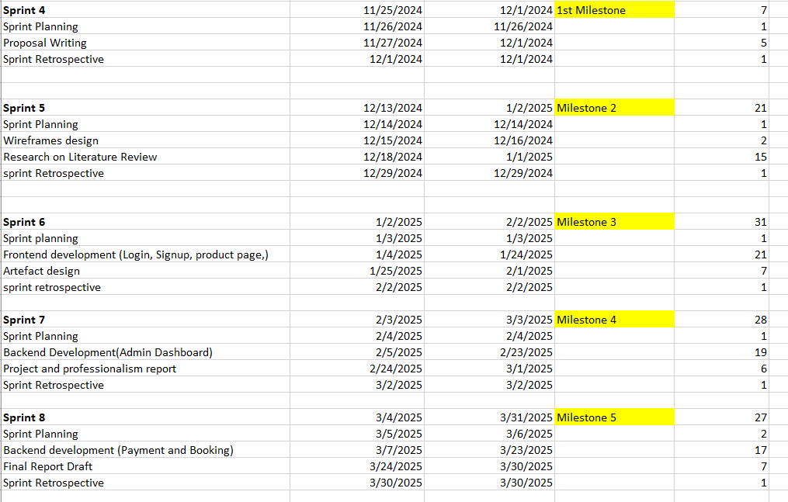

Figure 10 : Major Milestone Gantt Chart

## Different Tools and Technology

The technologies and tools used in this project were carefully selected to support modern web development practices, enable rapid iteration, and ensure scalability and maintainability. Given that the system is a full-stack web platform, it required responsive design, efficient server-side processing, a flexible database, and integration with external services like payment and notifications. All tools were chosen based on their reliability, community support, and alignment with the Scrum methodology.

**Frontend: React.js**

React was chosen because of its component-based architecture, which allowed reusable UI blocks for things like product cards, filter panels, and booking forms. Its virtual DOM ensures fast rendering, and it integrates well with state management tools for handling cart and user sessions.

**Backend: Node.js with Express.js**

Node.js was selected to keep the development entirely JavaScript-based across frontend and backend. Express.js provided a lightweight but powerful routing layer for managing APIs, such as booking, payments, user authentication, and notifications.

**Database: MongoDB**

MongoDB was chosen for its flexible, schema-less structure, which made it easy to store and manage various types of data like user profiles, equipment listings, and bookings. Its support for embedded documents and indexing improved data retrieval, while integration with Mongoose helped maintain validation and consistency.

**IDE: Visual Studio Code**

Visual Studio Code was selected for its lightweight design and powerful development features. It provided seamless support for both frontend and backend code, with helpful extensions for React, Node.js, and MongoDB. Built-in Git integration and debugging tools made development faster and more efficient.

**Version Control: GitHub**

Git was used for source code management, while GitHub served as the remote repository. The use of branches helped organize feature development sprint-wise, and pull requests made it easier to review and manage code changes. GitHub also enabled regular backups and tracking of project progress.

**Project Management: ClickUp**

ClickUp was chosen to support the Scrum methodology used throughout the project. It helped in breaking down the work into user stories and sprint tasks. Its dashboards, calendar view, and progress tracking features made it easier to monitor deadlines, sprint goals, and daily productivity.

**Design & Prototyping: Figma**

Figma was used for wireframing, interface design, and creating interactive prototypes. This allowed for early user feedback and rapid design adjustments before actual development began. It also made collaboration smoother by allowing real-time commenting and shared access during reviews.

**Use of Unit Testing and Mock Testing Frameworks**

During development, various testing techniques and tools were applied to ensure the reliability and performance of the Survey Equipment Rental Platform:

**Unit Testing (Jest & React Testing Library)**

Used to test individual frontend components such as login forms, product list, and booking interfaces. These tools allowed simulation of user interactions and validation of component behavior in isolation.

**Integration Testing (Postman)**

Postman was used to manually test RESTful API endpoints such as user registration, equipment booking, and payments. This ensured smooth communication between frontend and backend before full integration.

**Performance Testing (Apache JMeter)**

JMeter was used to simulate multiple users accessing the platform simultaneously, helping assess system performance under load and identify potential bottlenecks.

**User Acceptance and Usability Testing**

Final system testing was done with real users (e.g., surveyors and small business owners) to gather feedback on functionality, ease of use, and flow. Insights gained were applied to refine the system before submission.

**Use of Package Manager**

**Node Package Manager (NPM)**

NPM was used to manage all project dependencies and development tools for both frontend and backend. Libraries such as React, Express, Mongoose, Axios, dotenv, and bcrypt were installed and updated using NPM. It also allowed for script automation (start, test, build), ensuring consistent setup across development environments.

# **Artefact Designs**

## Sub System Milestone 1

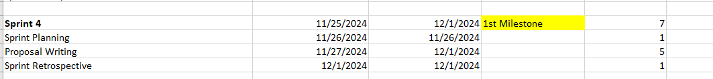

Figure 11: Subsystem Milestone 1

## **SRS Document**

### SRS for User Registration and Login (URL)

|  |  |  |
| --- | --- | --- |
| **Req. Code** | **Requirement Description** | **Priority** |
| URL-F-1.0 | The system shall allow users to register using email and password. | High |
| URL-F-1.1 | The system shall allow users to securely log in and log out. | High |
| URL-F-1.2 | The system shall support role-based login (Admin and Customer). | High |
| URL-F-1.3 | The system shall allow users to reset their passwords via email verification. | High |
| URL-NF-1.0 | Registration and login data shall be encrypted before transmission. | High |
| URL-UR-1.0 | The login and registration forms shall be mobile responsive and friendly | High |

### SRS for Equipment Search and Booking (ESB)

|  |  |  |
| --- | --- | --- |
| **Req. Code** | **Requirement Description** | **Priority** |
| ESB-F-1.0 | |  | | --- | | The system shall allow users to search equipment by type, price, and availability. | | High |
| ESB-F-1.1 | |  | | --- | | Users shall be able to view detailed equipment information before booking. | | High |
| ESB-F-1.2 | |  | | --- | | The system shall provide a status of real-time availability for each item. | | High |
| ESB-F-1.3 | |  | | --- | | The system shall allow users to add equipment to a cart before booking. | | High |
| ESB-F-1.4 | |  | | --- | | Users shall be able to select the rental duration and view the total cost. | | High |
| ESB-NF-1.0 | |  | | --- | | Search results shall load within 3 seconds under standard server conditions. | | High |
| ESB-UR-1.0 | |  | | --- | | The equipment listing page shall be responsive and visually accessible on mobile devices. | | Medium |

### SRS for Payment and Notification (PNM)

|  |  |  |  |  |
| --- | --- | --- | --- | --- |
| **Req. Code** | |  | | --- | | **Requirement Description** | | |  | | --- | | **Priority** | |
| PNM-F-1.0 | The system shall allow users to make secure payments using online gateways. | High |
| PNM-F-1.1 | Users shall receive payment confirmation and an invoice via email. | High |
| PNM-F-1.2 | The system shall notify users about booking status, payment success, or failure. | High |
| PNM-F-1.3 | The admin shall be notified of new bookings and payment completion. | Medium |
| PNM-NF-1.0 | Payment information shall be handled securely and not stored on the server. | High |
| PNM-UR-1.0 | The payment form shall include input validation and display user-friendly error messages. | High |

### SRS for Profile Management (PM)

|  |  |  |
| --- | --- | --- |
| **Req. Code** | **Requirement Description** | **Priority** |
| PM-F-1.0 | Users shall be able to view and update their profile information. | High |
| PM-F-1.1 | Users shall be able to change their password from their profile settings. | High |
| PM-F-1.2 | Admin shall be able to view and manage user accounts. | High |
| PM-UR-1.0 | Profile forms shall be accessible and easy to use on desktop and mobile devices. | Medium |

### SRS for Order Management (OM)

|  |  |  |
| --- | --- | --- |
| **Req. Code** | **Requirement Description** | **Priority** |
| OM-F-1.0 | The system shall allow users to confirm and place an order after selecting rental details. | High |
| OM-F-1.1 | The system shall update the order status (e.g., Ordered, Paid, Cancelled, Delivered, Returned) based on user and admin actions. | High |
| OM-F-1.2 | The system shall allow users to cancel or edit orders before rental start date. | High |
| OM-F-1.3 | The system shall allow users to extend rental dates if the product is available. | Medium |
| OM-F-1.4 | |  | | --- | |  |  |  | | --- | | The system shall notify users and admins when the order status changes. | | High |
| OM-NF-1.0 | |  | | --- | |  |  |  | | --- | | The order status update shall be reflected in real-time on the user's dashboard. | | Medium |
| OM-NF-1.1 | Order operations shall respond within 3 seconds under normal server load. | High |

### SRS for User Management (UM)

|  |  |  |
| --- | --- | --- |
| **Req. Code** | **Requirement Description** | **Priority** |
| UM-F-1.0 | The system shall allow users to register with full name, email, phone, and password. | High |
| UM-F-1.1 | |  | | --- | |  |  |  | | --- | | The system shall verify user email before activating the account. | | High |
| UM-F-1.2 | The system shall allow users to log in with email and password. | High |
| UM-F-1.3 | The system shall allow users to reset password via email OTP. | High |
| UM-F-1.4 | The system shall allow users to update their profile information. | Medium |
| UM-F-1.5 | The system shall allow users to view their order history. | Medium |
| UM-NF-1.0 | User data shall be securely stored and protected using encryption. | High |

### SRS for Admin Management (AM)

|  |  |  |
| --- | --- | --- |
| **Req. Code** | **Requirement Description** | **Priority** |
| AM-F-1.0 | The admin shall be able to view, filter, and manage all orders in the system. | High |
| AM-F-1.1 | |  | | --- | |  |  |  | | --- | | The admin shall be able to approve or reject orders based on availability or validation. | | High |
| AM-F-1.2 | The admin shall be able to manage product listings (add, update, delete). | High |
| AM-F-1.3 | The admin shall be able to view and manage registered users. | High |
| AM-F-1.4 | The admin shall be notified of COD orders for manual verification. | Medium |
| AM-NF-1.0 | Admin actions shall be logged for audit purposes. | Medium |
| AM-NF-1.1 | The admin dashboard shall load within 2 seconds for up to 1000 orders. | High |

## **Designs**

## Entity Relationship Diagram

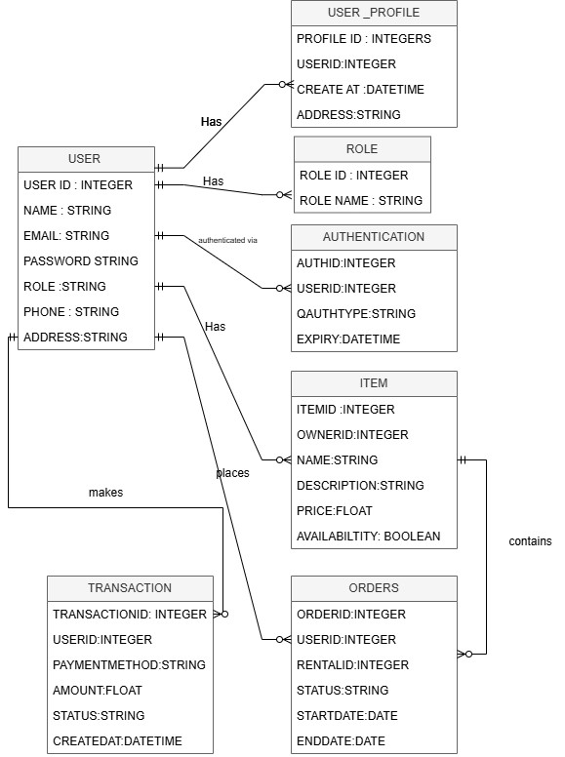

Figure 12 : ERD Diagram

Use Case Diagram

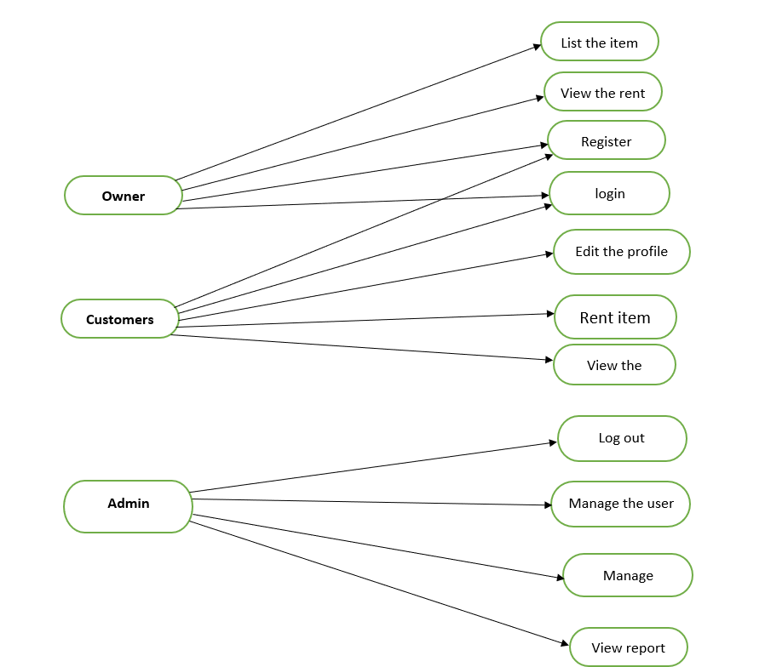

Figure 13: Use Case Diagram

Class Diagram

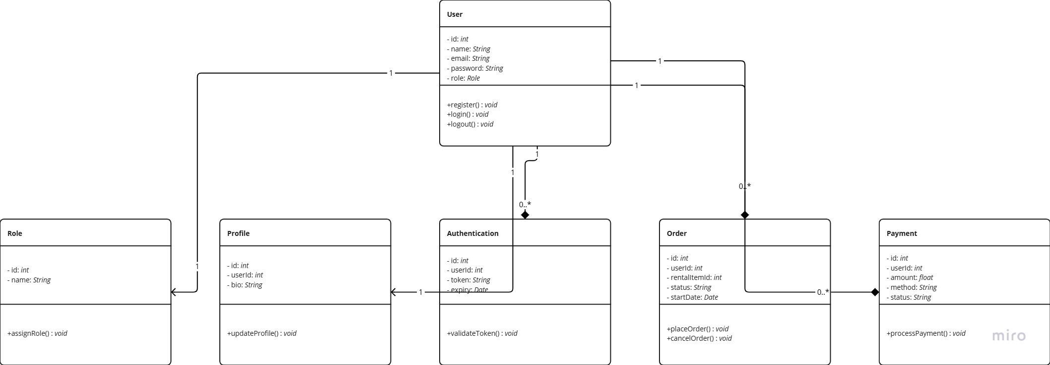

Figure 14 : Class Diagram

## **Activity Diagram**

### User Registration

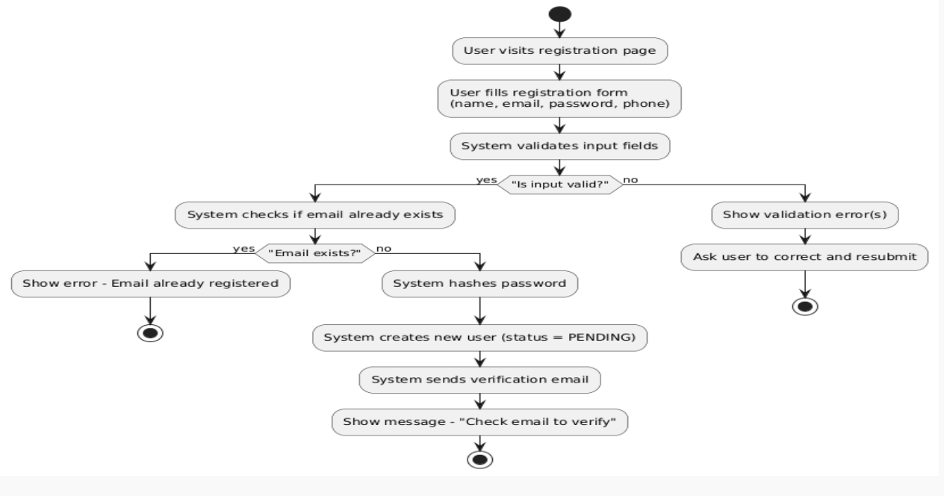

Figure 15: User Registration Activity Diagram

The diagram shows the step-by-step process of sign-up. It includes form filling, input validation, email existence check, password hashing, and verification email dispatch. The flow ensures only properly verified users are created and notified to confirm their email.

### User Login

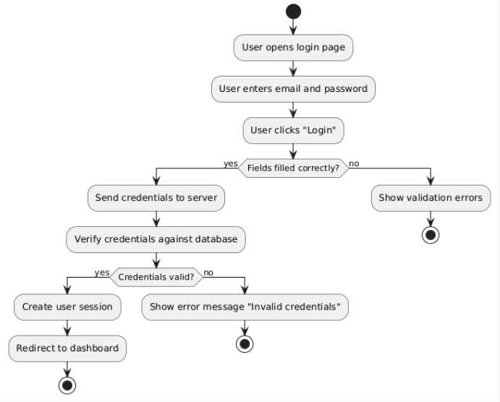

Figure 16: User Login Activity Diagram.

After the user inputs their email and password, the system validates the entries. If credentials are correct, a session is created and the user is redirected; otherwise, error messages are displayed.

### Forget Password

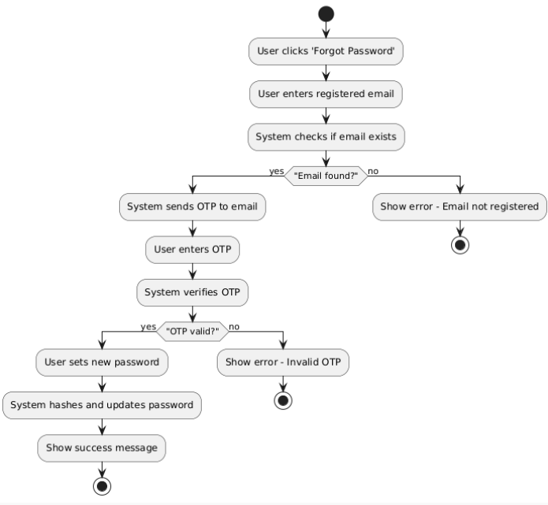

Figure 17: Activity Diagram of Forgot Password

The user provides their registered email, and the system verifies its existence. If valid, an OTP is sent, verified, and upon success, the user resets their password; otherwise, appropriate error messages are shown.

## **Sequence Diagram**

### User Registration

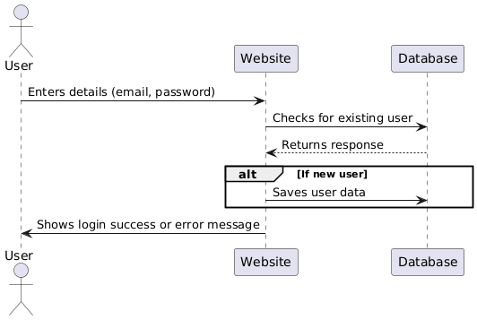

Figure 18: Sequence Diagram of User Registration

The user registration process where a user submits email and password to the website. The system checks the database for an existing user, and if none is found, saves the new user data. Finally, it returns a success or error message to the user.

User Login

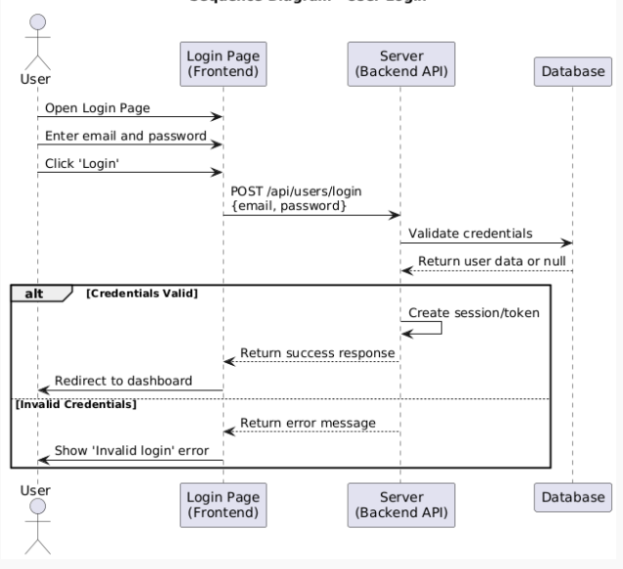

Figure 19: Sequence Diagram of User Login.

Diagram illustrates how a user enters credentials on the frontend, which are sent to the server for validation. If credentials are valid, the server generates a session token and redirects the user to the dashboard. If invalid, an error message is returned and shown on the login page.

### Forgot Password

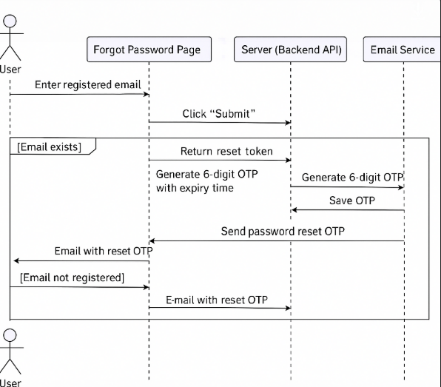

Figure 20:Sequence Diagram of Forgot Password

If the entered email exists in the database, the system generates a One-Time Password (OTP) or token, stores it with an expiry time, and sends it to the user's email. This OTP is then used to securely verify identity before allowing the user to reset their password.

## **Communication Diagram**

### User Registration

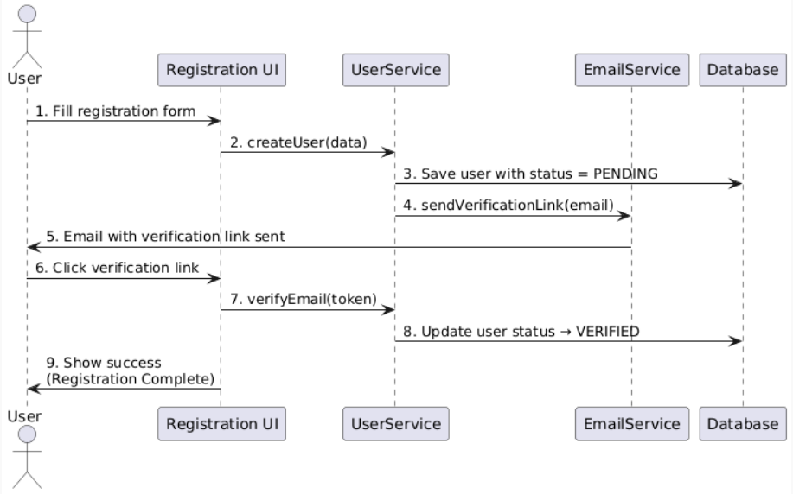

Figure 21: User Registration Communication Diagram

This diagram illustrates the user registration flow. After the user submits the form, their data is saved with a "PENDING" status and a verification link is emailed. Upon clicking the link, the system verifies the token and marks the user as "VERIFIED".

### User Login

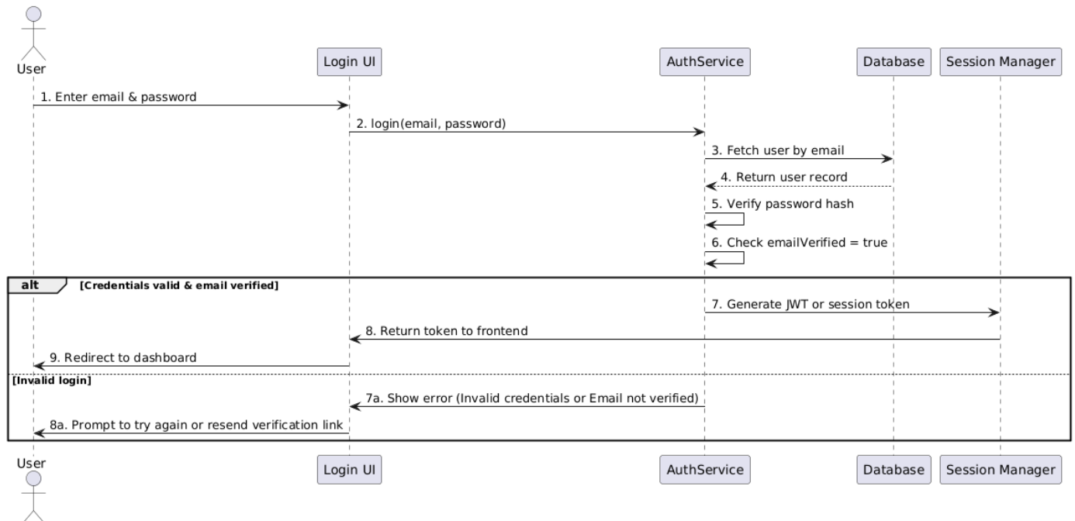

Figure 22: User Login Communication Diagram

This diagram explains the user login process. The system verifies credentials and email status, then issues a session token upon success. If login fails, it returns an appropriate error and prompts the user to retry or verify their email.

### Forgot Password

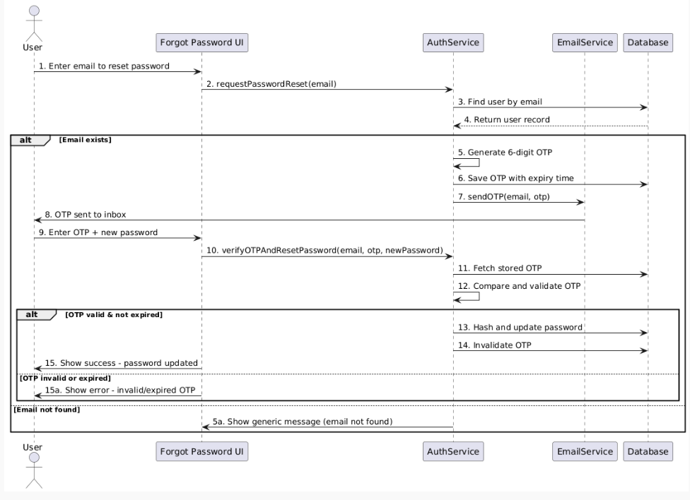

Figure 23: Forgot Password Communication Diagram

This communication diagram illustrates the process of resetting a password via OTP. The user submits an email, the system validates it, generates and sends an OTP if valid, then verifies the OTP and updates the password. It also handles edge cases like invalid or expired OTP and non-existent emails.

## **User Management**

### Use Case

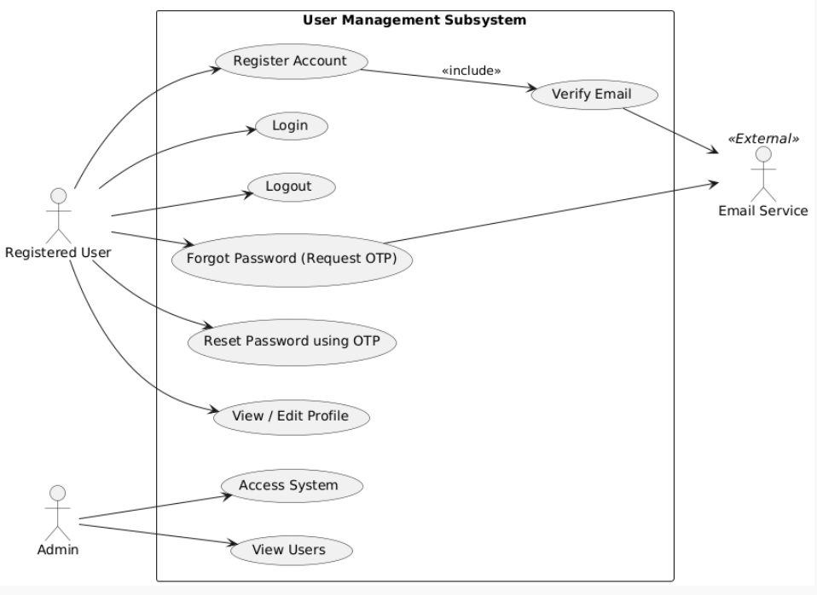

Figure 24: User Management Use Case

This use case diagram models the User Management Subsystem where registered users can register, log in, reset passwords, and edit profiles. Admins can access the system and view users. Email Service is an external actor responsible for sending verification and OTP emails.

### Activity Diagram

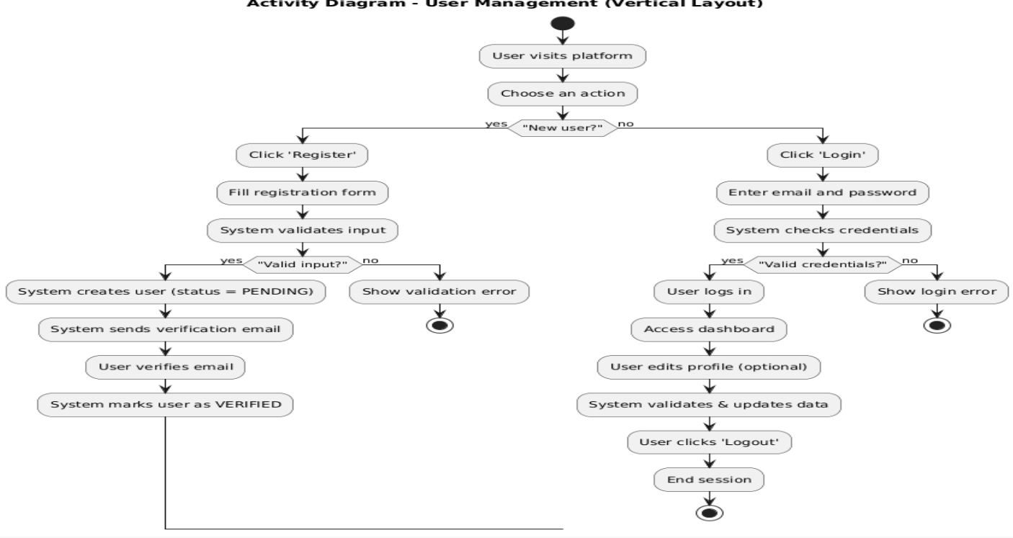

Figure 25: User Management Activity Diagram

The User Management Activity Diagram shows two main flows: user registration and login. New users register, validate input, verify email, and get marked as verified. Existing users log in, access their dashboard, optionally update their profile, and log out.

### Class Diagram

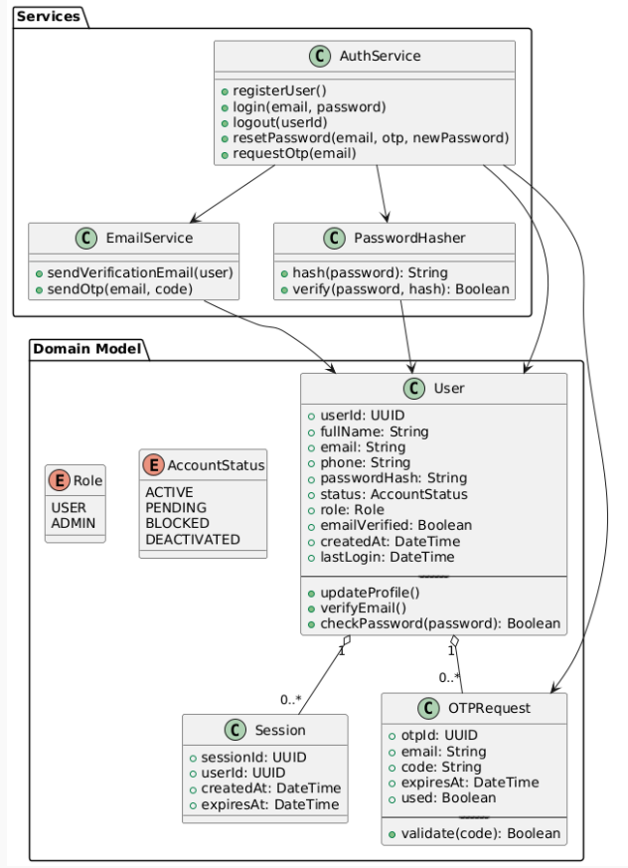

Figure 26: User Management Class Diagram

The class diagram represents the User Management system with AuthService coordinating authentication using EmailService and PasswordHasher. The User entity stores personal, security, and account state details using Role and AccountStatus enums. Each user can have multiple sessions and OTP requests for access and verification.

### ER Diagram

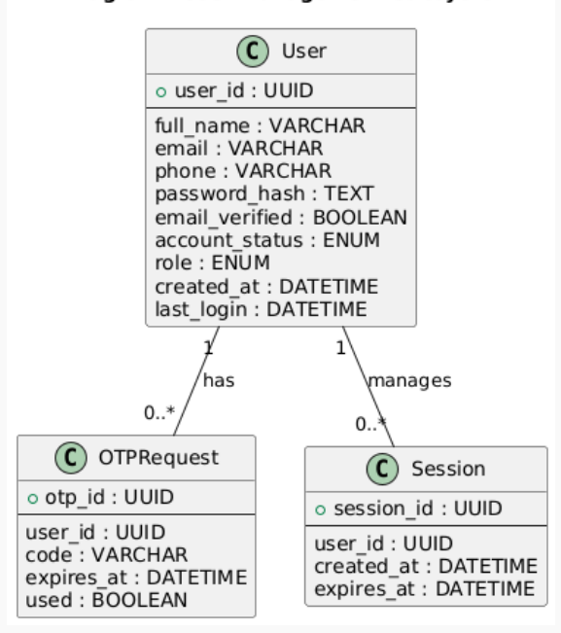

Figure 27: User Management ER Diagram

This diagram shows the relationships in user management, where a user can have multiple OTP requests and login sessions. The User entity stores personal and authentication details, including enums for role and account status. OTPRequest tracks one-time passwords for verification, and Session manages user login tracking.

### Sequence Diagram

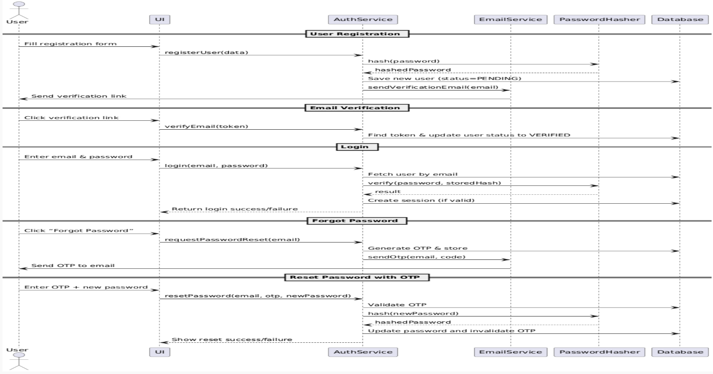

Figure 28: User Management Sequence Diagram

The diagram captures how users register, verify emails, log in, and reset passwords securely. It shows interactions between the user, UI, and backend services like AuthService and EmailService. Each flow ensures secure handling using hashing, OTP, and validation checks.

## **Order Management**

### Class Diagram

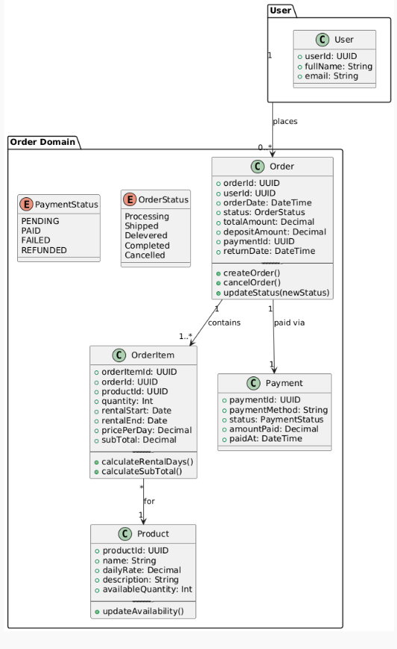

Figure 29: Order Management Class Diagram

This diagram outlines classes like Order, Payment, OrderItem, and their links to User and Product. It defines how an order includes multiple items, is associated with a user and payment, and tracks statuses using enumerations. The classes include operations like creating, cancelling orders, and calculating totals.

### ER Diagram

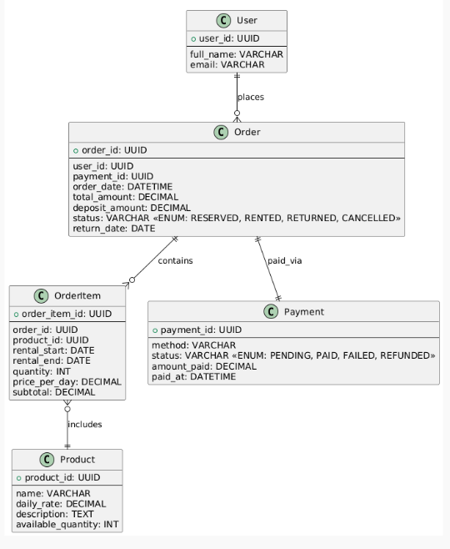

Figure 30: Order Management ER Diagram

This diagram shows the relationship between users, orders, payments, products, and order items. Each user can place multiple orders, which are linked to payment records and contain multiple products. It captures detailed rental info like duration, quantity, and financial status for effective tracking.

### Activity Diagram

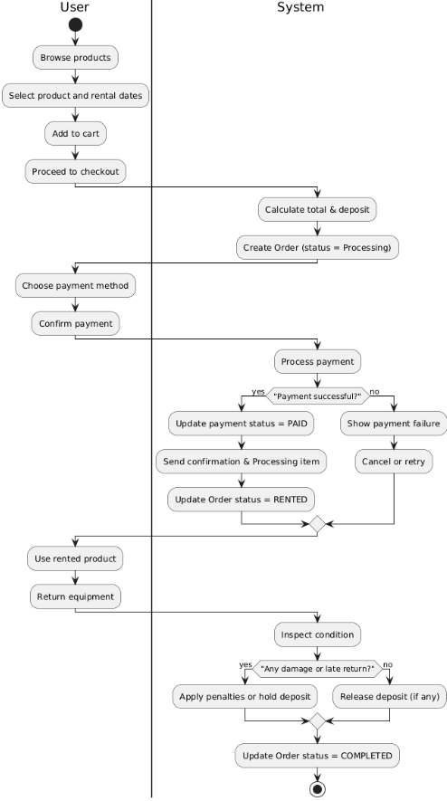

Figure 31: Order Management Activity Diagram

The diagram outlines how a user browses, adds a product to the cart, makes payment, and returns the equipment. The system processes the order, updates statuses, and handles deposits based on item condition. It ensures a complete rental flow from booking to return.

### Use Case Diagram

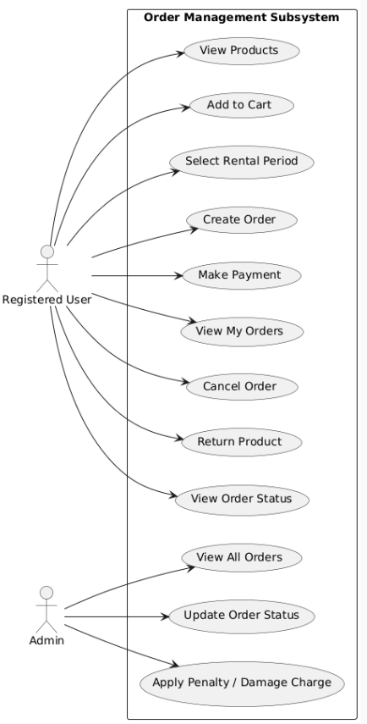

Figure 32: Order Management Use Case Diagram

The diagram outlines actions performed by registered users and admins in managing orders. Users can browse products, create and cancel orders, make payments, and track order status. Admins oversee all orders, update statuses, and apply penalties or damage charges.

### Sequence Diagram

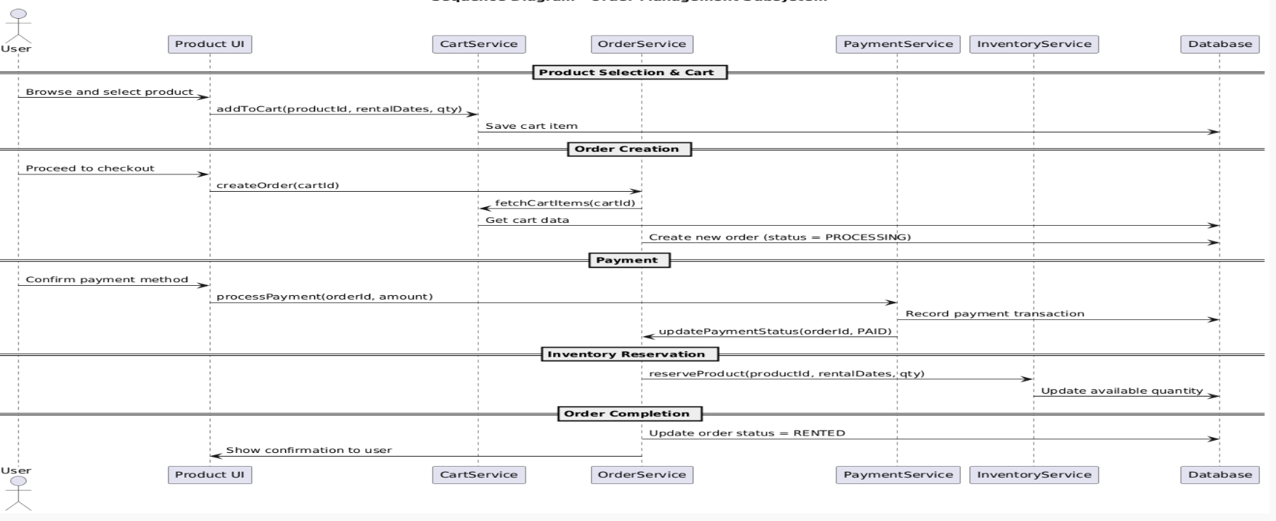

Figure 33: Order Management Sequence Diagram

The diagram illustrates the full flow from product selection to order confirmation. It covers adding items to cart, creating the order, processing payment, reserving inventory, and updating order status. Each service Cart, Order, Payment, Inventory interacts with the database to complete the process.

## **Activity Diagram**

### User Confirms Order

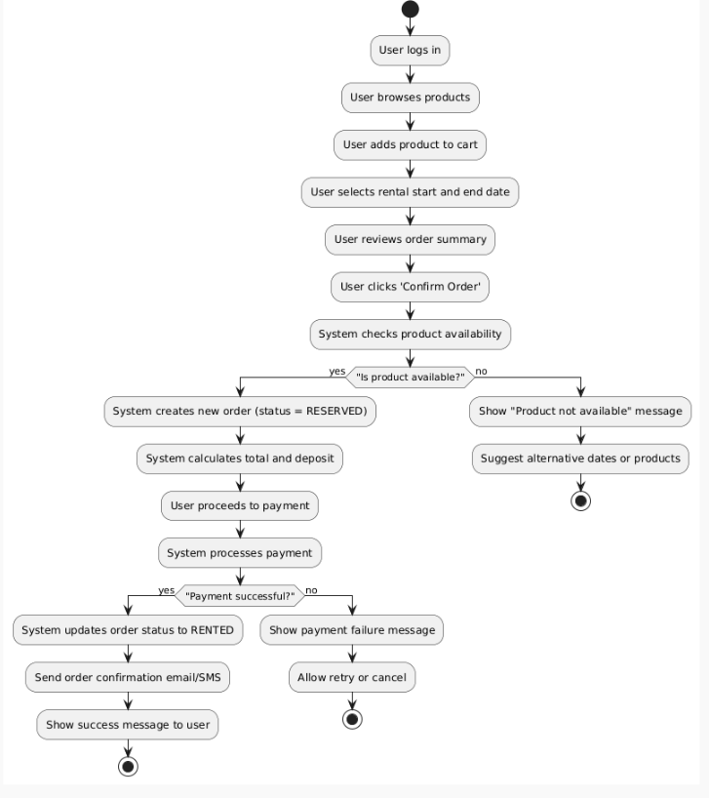

Figure 34: Activity Diagram User Confirms Order

The diagram shows how a user browses product, selects rental dates, and confirms an order. The system checks availability, reserves the item, calculates payment, and processes it. If successful, it updates the order to RENTED and notifies the user.

### User Extend Order

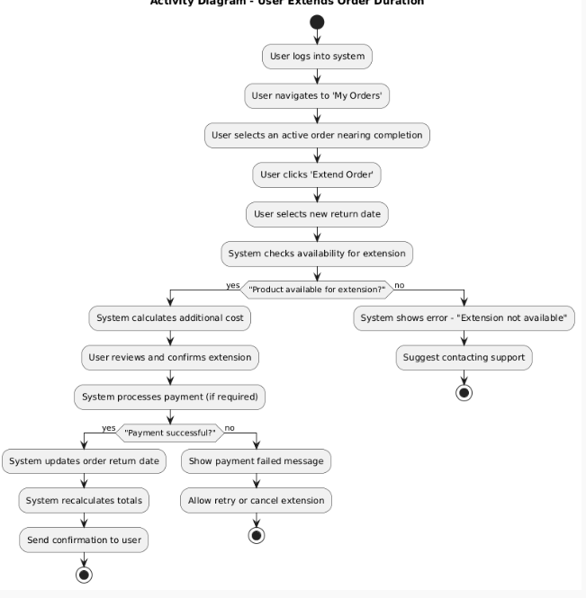

Figure 35: Activity Diagram User Extend Order

The diagram shows how a user extends a nearing-completion order by selecting a new return date. The system checks availability, calculates extra cost, and processes payment if needed. Upon success, it updates the order and sends a confirmation; otherwise, it shows an error or retry option.

### User Cancel Order

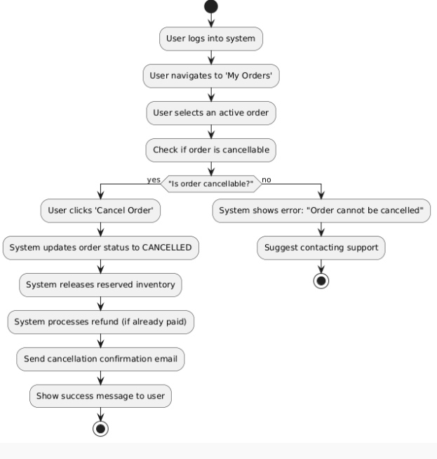

Figure 36: Activity Diagram of User Cancel Order

The diagram shows how a user cancels an active order from the 'My Orders' section. If the order is cancellable, the system updates its status, releases inventory, processes refunds, and notifies the user. If not, it shows an error and suggests contacting support.

### User Edit Order

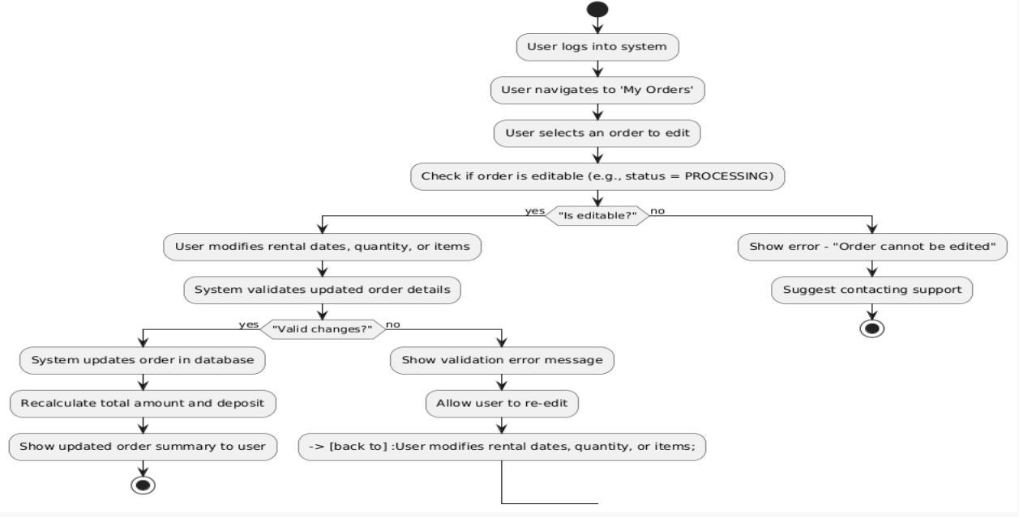

Figure 37: Activity Diagram User Edit Order

The diagram shows how a user logs in, navigates to their orders, and selects one to edit. If the order is editable, the user modifies details and the system validates and updates the changes. If invalid or not editable, the system shows an error or prompts re-edit.

### Admin Accepts Order

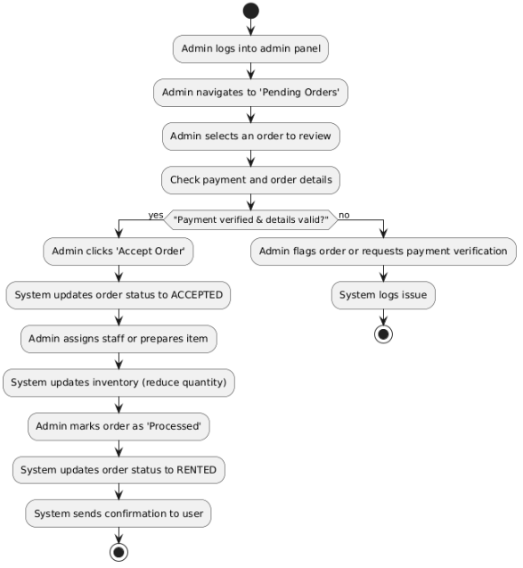

Figure 38:Activity Diagram Admin Accepts Order

The diagram shows how an admin reviews and accepts valid pending orders. Upon acceptance, the system updates the order status, reduces inventory, and prepares the item. The order is marked as processed, confirmed to the user, and set to RENTED.

### Admin Cancel Order

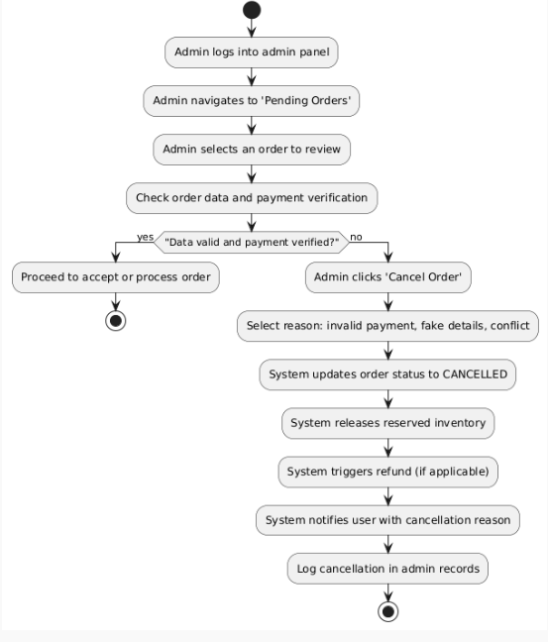

Figure 39: Activity Diagram Admin Cancel Order

The diagram shows how an admin reviews pending orders and verifies their details. If issues are found, the admin cancels the order with a reason, updates its status, and initiates refunds or inventory release. The system then notifies the user and logs the cancellation.

## **Product Management**

### ER Diagram

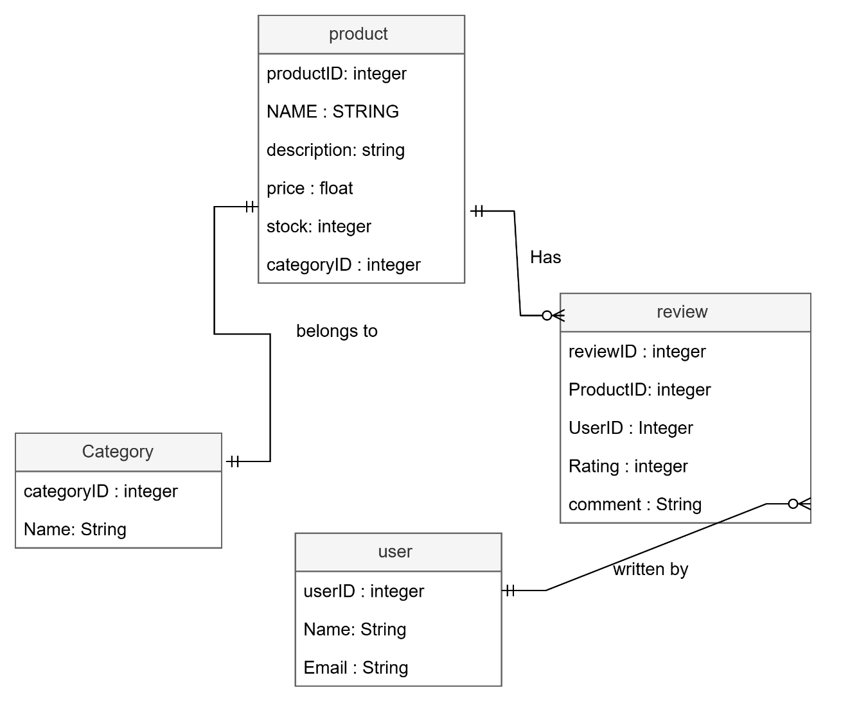

Figure 40: ER Diagram of Product Management

The diagram shows that each product belongs to a category and can receive multiple reviews. Reviews are linked to both products and the users who wrote them. This structure ensures traceable product categorization and feedback relationships.

### Class Diagram

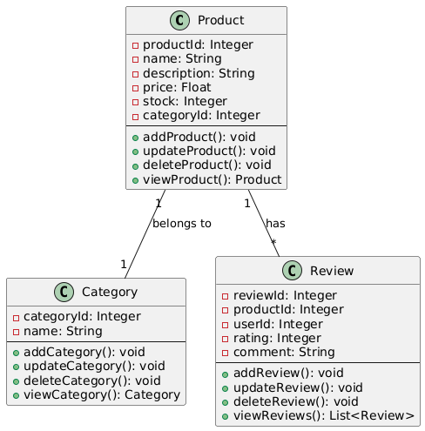

Figure 41: Class Diagram of Product Management.

The diagram shows that each product belongs to a category and can have multiple reviews. The Product class manages creation, updates, and deletions, while Category and Review support classification and user feedback. It organizes product data and operations clearly.

### Activity Diagram

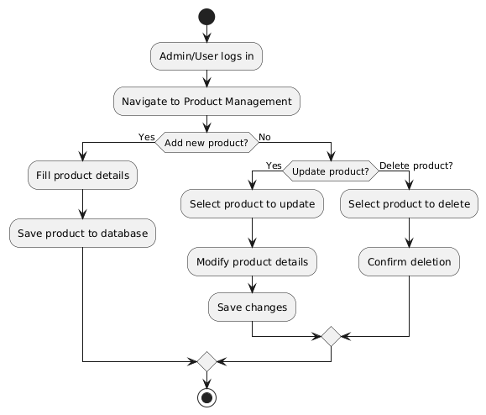

Figure 42: Activity Diagram of product Management.

The diagram shows how an admin or user manages products by logging in and navigating to the product section. Based on the action—add, update, or delete—the system performs the appropriate operation. Each action ends with saving changes or confirming deletion in the database.

### Use Case Diagram

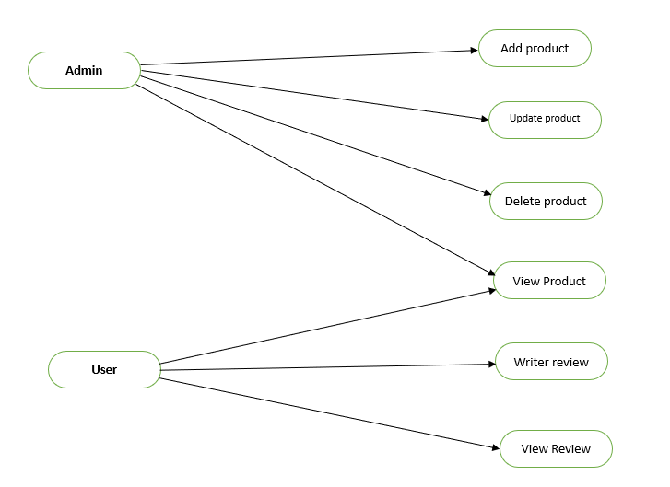

Figure 43: Use Case Diagram of Product Management.

The diagram shows that admins can add, update, delete, and view products on the platform. Users can view available products and write or read reviews. It separates management functions from user interactions with product listings.

### Sequence Diagram

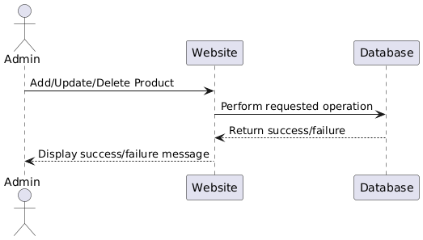

Figure 44: Sequence Diagram of Product Management.

The diagram shows how the admin requests to add, update, or delete a product. The website processes the request by interacting with the database. A success or failure message is returned and displayed to the admin.

## **Checkout Management**

### ER Diagram

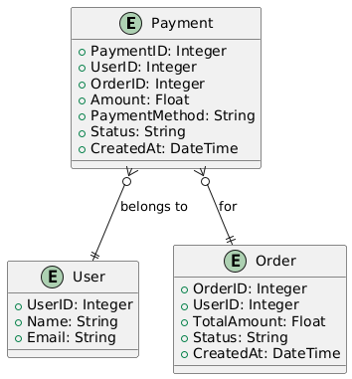

Figure 45 : ER Diagram of checkout Management.

The diagram shows that each payment is linked to both a user and a specific order. It stores payment details like amount, method, status, and timestamp. This structure ensures traceability and secure mapping of transactions to users and orders.

### Class Diagram

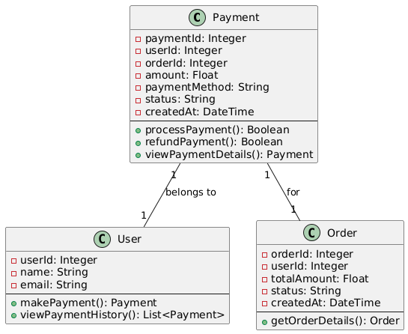

Figure 46: Class Diagram of checkout Management.

The diagram shows that each payment is linked to a user and an order. The Payment class handles processing, refunds, and viewing payment details. It connects with User and Order to maintain transaction integrity.

### Activity Diagram

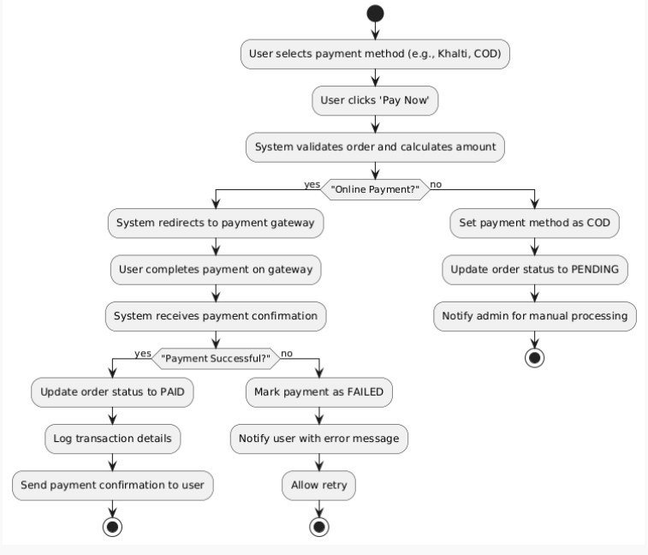

Figure 47:Activity Diagram of checkout Management

The diagram shows the flow after a user selects a payment method and clicks 'Pay Now'. The system processes the payment through an online gateway or marks it as COD. Based on success or failure, it updates the order status and notifies the user.

### Use Case Diagram

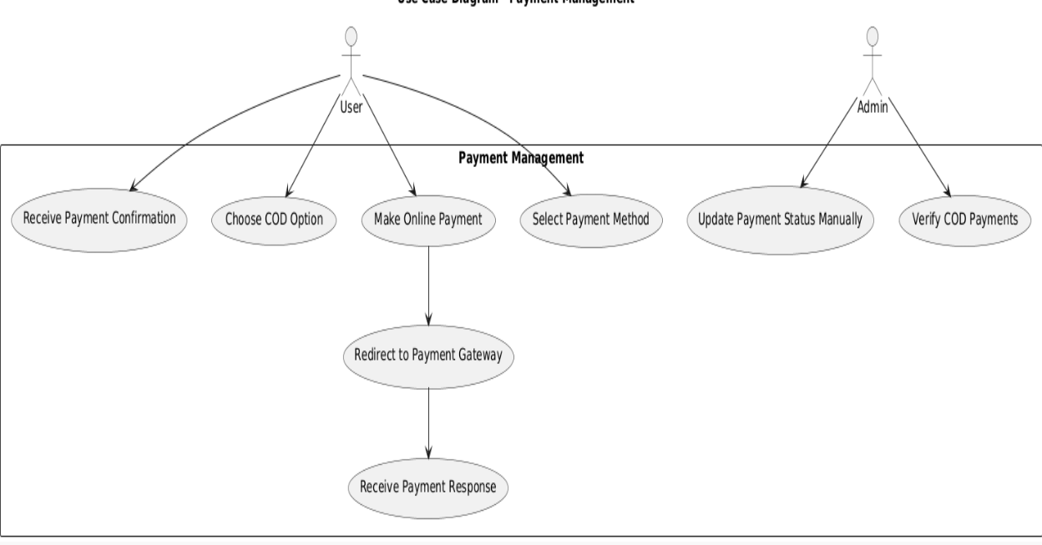

Figure 48: Use Case Diagram of Checkout Management

The diagram shows how users choose a payment method and complete the transaction. It includes both online payment and COD options. Admins handle COD verification and update payment status manually.

### Sequence Diagram

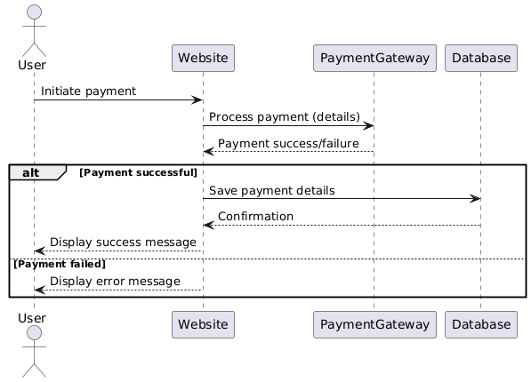

Figure 49: Sequence Diagram of checkout Management.

The diagram shows how a user initiates a payment through the website. It handles success or failure responses from the payment gateway. Based on the result, the system saves details and shows a success or error message.

## **Notification Management**

### ER Diagram

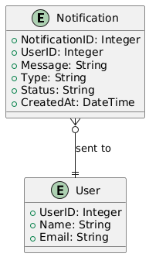

Figure 50: ER Diagram of Notification Management.

The diagram shows that each notification is linked to a specific user by UserID. Notifications store details like message, type, status, and timestamp. It helps track which messages were sent to which users.

### Class Diagram

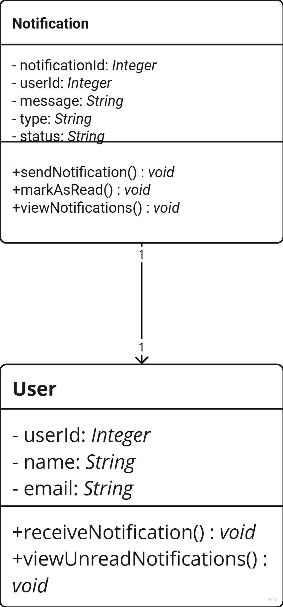

Figure 51: Class Diagram of Notification Management.

The diagram shows that each user can receive multiple notifications linked by userId. The Notification class handles sending, viewing, and marking messages as read. The User class includes methods to receive and check unread notifications.

### Activity Diagram

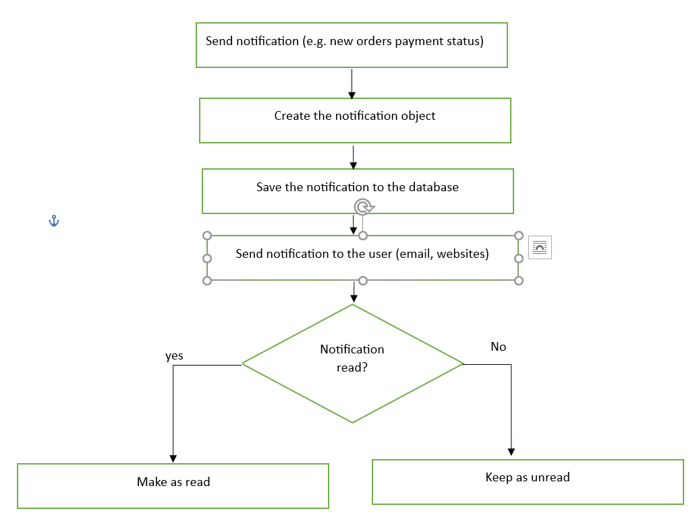

Figure 52: Activity Diagram of Notification Management.

The diagram shows how the system creates and sends a notification to the user after an event occurs. It stores the notification in the database and delivers it via email or web. Based on user interaction, it is marked as read or left unread.

### Use Case Diagram

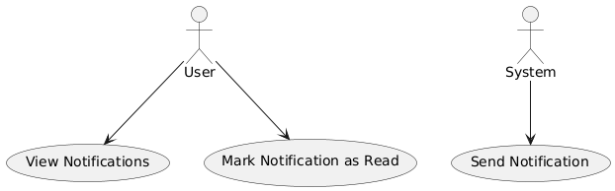

Figure 53: Use Case Diagram of Notification Management.

The diagram shows how users can view and mark notifications as read. The system automatically sends notifications based on events like orders or payments. It separates user-initiated actions from system-generated ones.

### Sequence Diagram

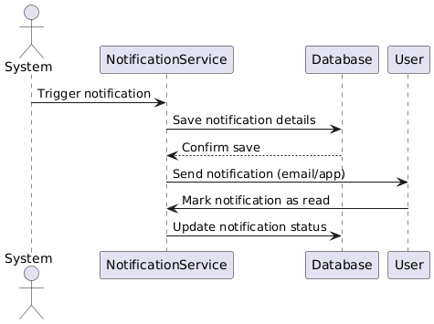

Figure 54: Sequence Diagram of Notification Management.

The diagram shows how the system triggers a notification event and saves it via the notification service. Once stored, it is sent to the user through email or app. When the user reads it, the system updates its status in the database.

## **Wireframes**

## **Testing**

|  |  |  |  |  |  |
| --- | --- | --- | --- | --- | --- |
| Test Case ID | Test Name | Test Description | Expected Result | Observation | Result |
| T01 | Login | Verify that users can log in with valid credentials. | User should be able to log in and access the dashboard. | User successfully logged in with valid credentials, and access to the dashboard was granted. | Pass |

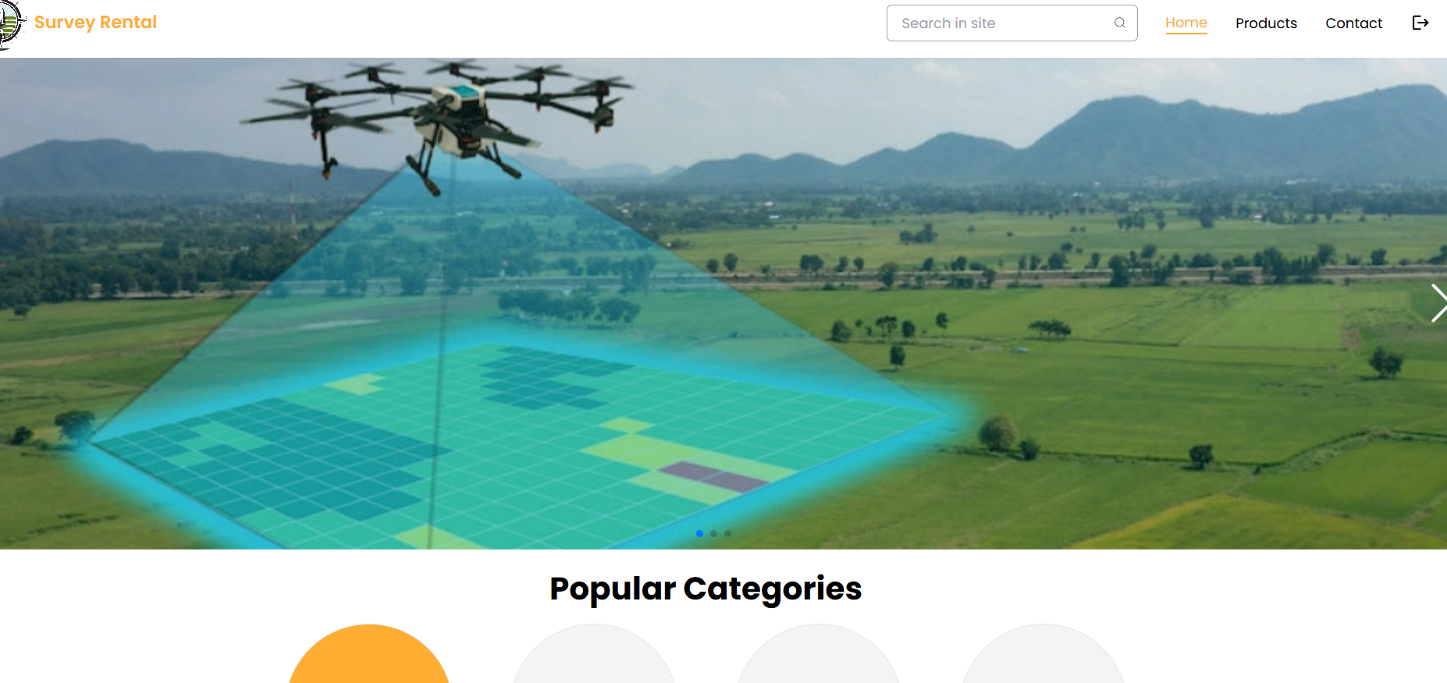

Figure 55: Login Testing

|  |  |  |  |  |  |
| --- | --- | --- | --- | --- | --- |
| Test Case ID | Test Name | Test Description | Expected Result | Observation | Result |
| T02 | Invalid Login | Verify that an error message appears for incorrect credentials. | User should see an error message when using invalid credentials | User entered incorrect credentials, and an error message was displayed. | Pass |

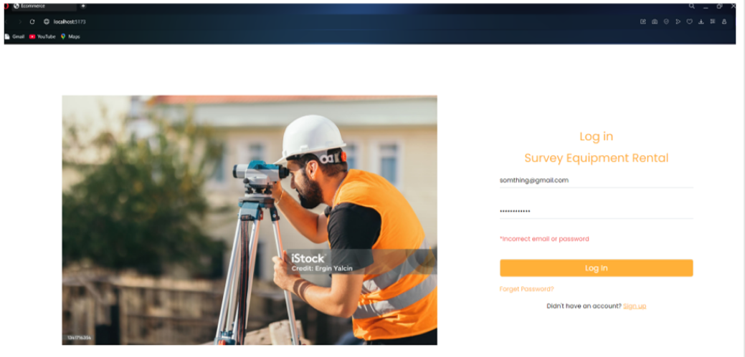

Figure 56: Testing of Invalid Login

|  |  |  |  |  |  |
| --- | --- | --- | --- | --- | --- |
| Test Case ID | Test Name | Test Description | Expected Result | Observation | Result |
| T03 | User Registration | Verify that a new user can successfully register. | User should be able to create an account. | User filled out the registration form, submitted it, and received confirmation | Pass |



Figure 57: User Registration Testing

|  |  |  |  |  |  |
| --- | --- | --- | --- | --- | --- |
| Test Case ID | Test Name | Test Description | Expected Result | Observation | Result |
| T04 | Browse Equipment | Ensure that users can view the list of available survey equipment. | Equipment list should be displayed properly. | User navigated to the equipment page, and all items were displayed correctly. | Pass |

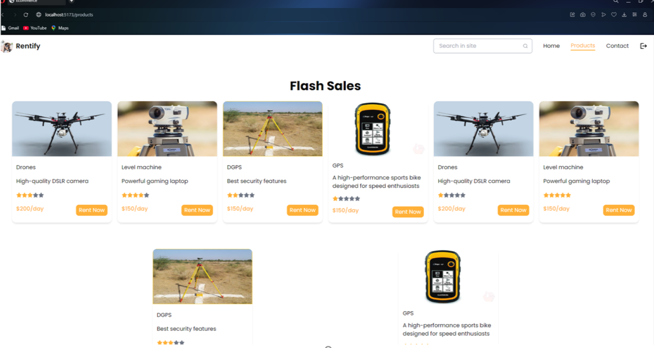

Figure 58: Equipment Browsing Testing

|  |  |  |  |  |  |
| --- | --- | --- | --- | --- | --- |
| Test Case ID | Test Name | Test Description | Expected Result | Observation | Result |
| T05 | Equipment Details | Verify that users can view detailed information on an item. | Clicking on an item should open a details page. | User clicked on an item, and the detailed information was displayed correctly. | Pass |

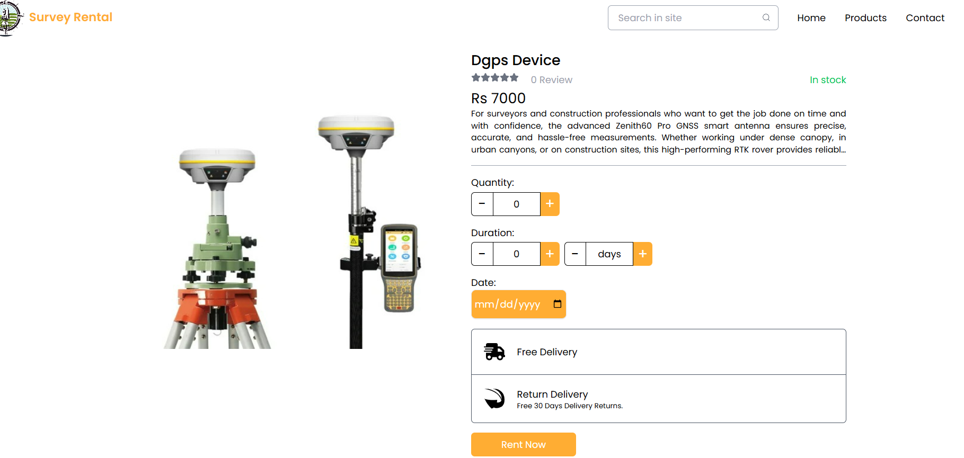

Figure 59: Equipment Details Showing Testing

|  |  |  |  |  |  |
| --- | --- | --- | --- | --- | --- |
| Test Case ID | Test Name | Test Description | Expected Result | Observation | Result |
| T06 | Checkout page | Verify that the checkout page is shown correctly. | The checkout page should show all the input fields and users can fill the form. | User was shown the checkout form correctly and user was able to fill all the input fields. | Pass |

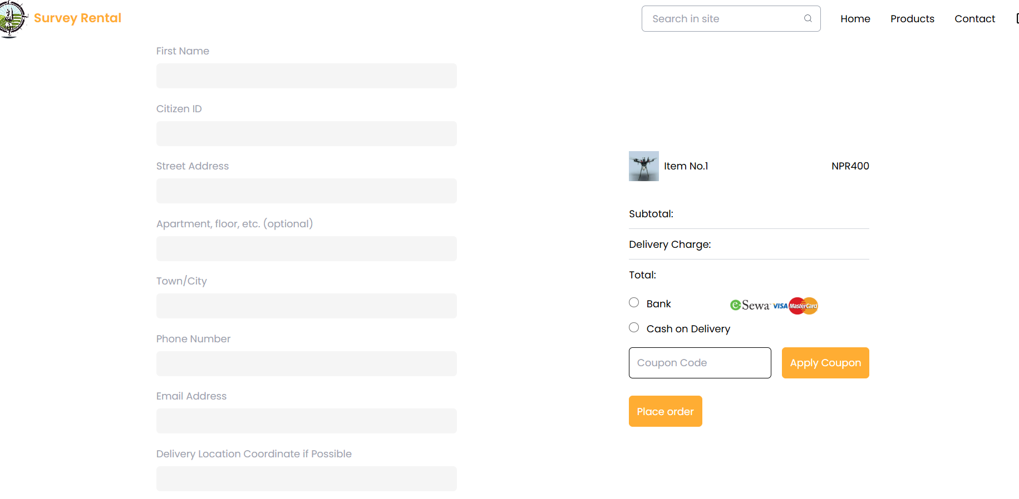

Figure 60 : Testing of Checkout Page

|  |  |  |  |  |  |
| --- | --- | --- | --- | --- | --- |
| Test Case ID | Test Name | Test Description | Expected Result | Observation | Result |
| T07 | Logout | Ensure users can log out and be redirected to the login page. | Users should be logged out and redirected to the login page. | User clicked 'Logout' and was redirected to the login page. | Pass |

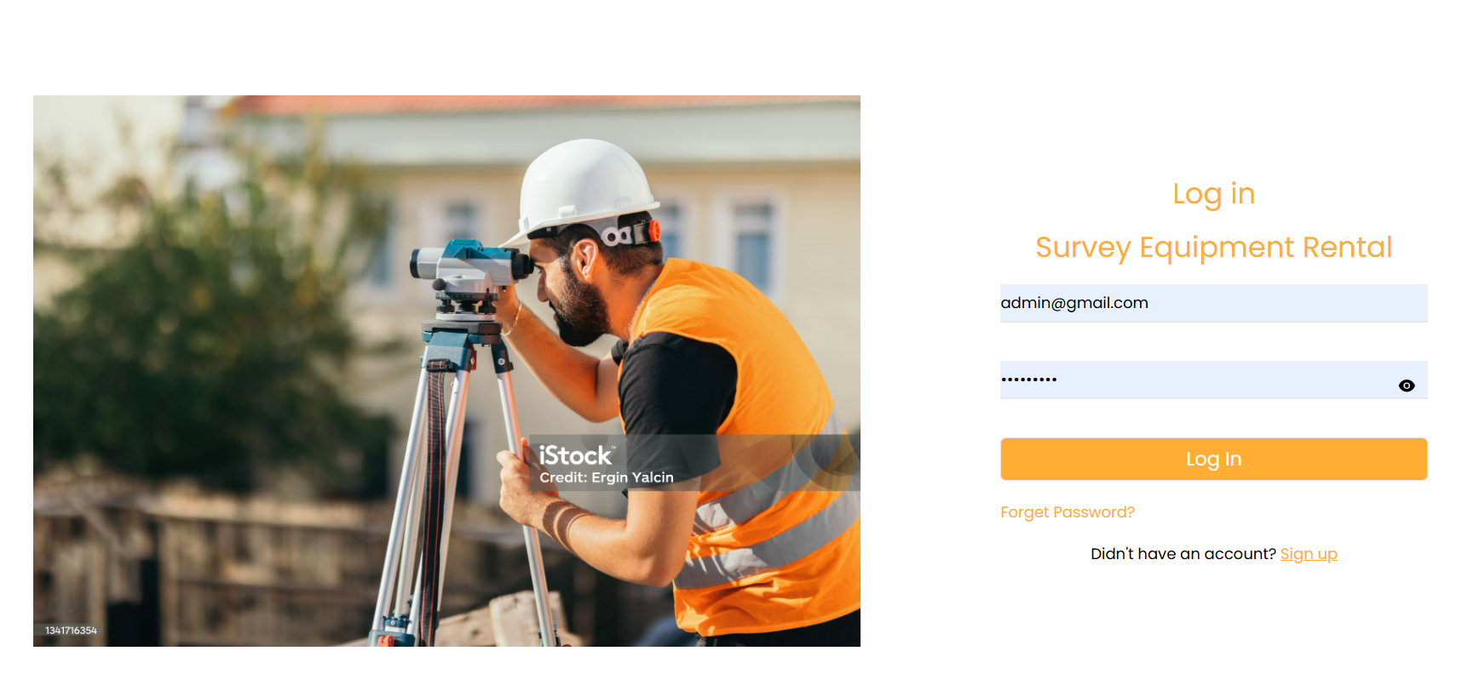

Figure 61: Logout Testing

## Sub System 2

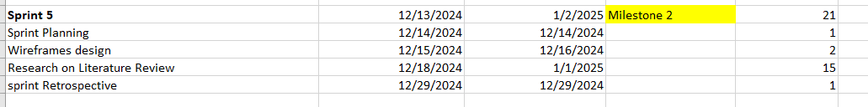

Figure 62: Subs System Milestone 2

## Sub System 3

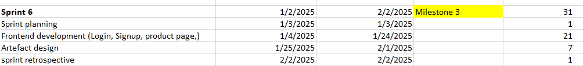

Figure 63: Sub System Milestone 3

## Sub System 4

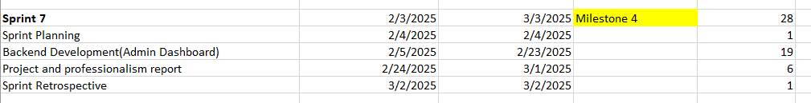

Figure 64: Sub System Milestone 4

## Sub System 5

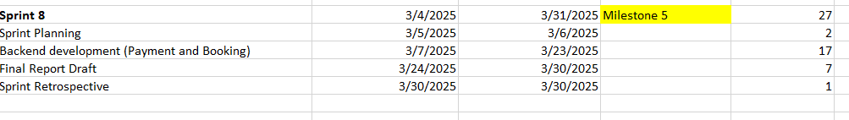

Figure 65: Sub System Milestone 5

# **Conclusion**

The development of the Survey Equipment Rental platform has successfully fulfilled its core aims, objectives, and academic questions by delivering a functional, user-centered digital solution that modernizes the process of renting survey tools in Nepal. The system addresses long-standing challenges such as poor accessibility, lack of transparency, and inefficient manual processes that previously affected surveyors and small businesses. By offering a centralized rental platform with features like dynamic pricing, real-time availability, and secure booking, the project has reshaped how survey equipment can be accessed and managed.

Key functionalities including user registration, profile management, equipment filtering, rental cart management, automated notifications, and secure transactions were all designed and implemented using a full-stack approach with React.js, Node.js, Express.js, and MongoDB. Agile Scrum methodology ensured iterative development and consistent feedback integration. Although some advanced features such as mobile app support, multilingual options, and delivery tracking were outside the current scope, the system lays a strong foundation for future expansion and scalability.

## **Reflecting Aims and Objectives**

The Survey Equipment Rental system has effectively met its primary aims by providing a centralized digital solution that simplifies access to high-cost survey equipment. The platform replaces manual rental processes with a user-friendly interface, allowing users to browse categorized tools, check availability, and book securely online aligning with the aim to improve efficiency and transparency.

Moreover, core objectives such as account management, dynamic pricing, secure payment integration, and real-time notifications have been successfully implemented. These features ensure a seamless rental experience and build user trust. Admin-side control supports inventory management and ensures consistent equipment availability. The system also supports long-term goals by being scalable and adaptable to future enhancements. By meeting the defined aims and objectives, the platform demonstrates its effectiveness in addressing key industry gaps and improving access for independent surveyors and small businesses across Nepal.

Academic Questions and System Impact

* How can an e-commerce platform simplify survey equipment rentals for better customer retention?

The platform simplifies equipment access by allowing users to browse listings, apply filters, and book rentals online. Features like booking history, profile management, and real-time updates contribute to a seamless experience that improves customer satisfaction and encourages repeat use.

* How can accessibility and efficiency in survey equipment rentals be improved through e-commerce?

The system removes physical and communication barriers by centralizing all rental tasks into a single digital platform. Users can view up-to-date availability, make instant bookings, and receive notifications—greatly improving the speed, convenience, and accuracy of equipment access.

* How can an e-commerce platform optimize costs and support growth for small survey businesses?

Dynamic pricing enables cost-effective renting during low-demand periods, while eliminating the need for full equipment ownership. This flexibility lowers the financial burden on small survey firms and opens new opportunities for scaling operations using on-demand tools.

# **Critical Evaluation**

The Survey Equipment Rental platform, built using React.js, Node.js with Express.js, and MongoDB, has been successfully developed and deployed. The successful outcome of the project is credited to the proper use of modern web technologies and their effective integration to build a functional, user-friendly, and scalable platform. The system addresses long-standing challenges in Nepal’s survey equipment rental industry and introduces a reliable digital solution. Despite the project’s strengths, there were still areas where further technical exploration and refinement could have been achieved with more time and resources. The entire process provided meaningful insights into modern system development practices and user-centric design.

## Final Report

While preparing the final report for the Survey Equipment Rental platform, I encountered several challenges that pushed me both technically and mentally. I worked hard to ensure that the report clearly explained the development journey, covering how the core subsystems like user registration, product management, booking, secure payments, and notifications were created and integrated. The report also reflects on the problems surveyors face in Nepal’s traditional rental system and how this digital platform provides a more organized and efficient solution. I focused on presenting each feature in a way that connects with real-world needs.

The literature review section was particularly demanding. Finding academic sources directly related to survey equipment rental was not easy, so I had to explore Google Scholar, Semantic Scholar, and other academic sites. After gathering the papers, I watched several tutorial videos to better understand how to structure the literature review properly and make it relevant to my system. This process helped me build a solid academic background for my project.

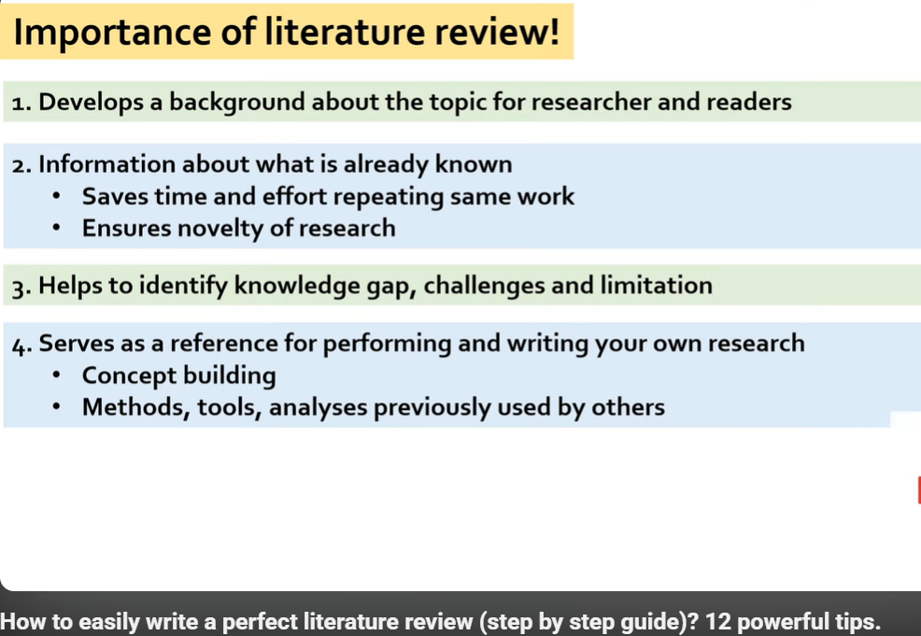

Figure 66: How to easily write perfect literature review.

The artefact design part was another time-consuming area. Creating ER diagrams, activity diagrams, and sequence diagrams took patience and care. To fully understand how to draw an activity diagram and map out system logic, I watched step-by-step video guides and referred to my lecture materials and examples.

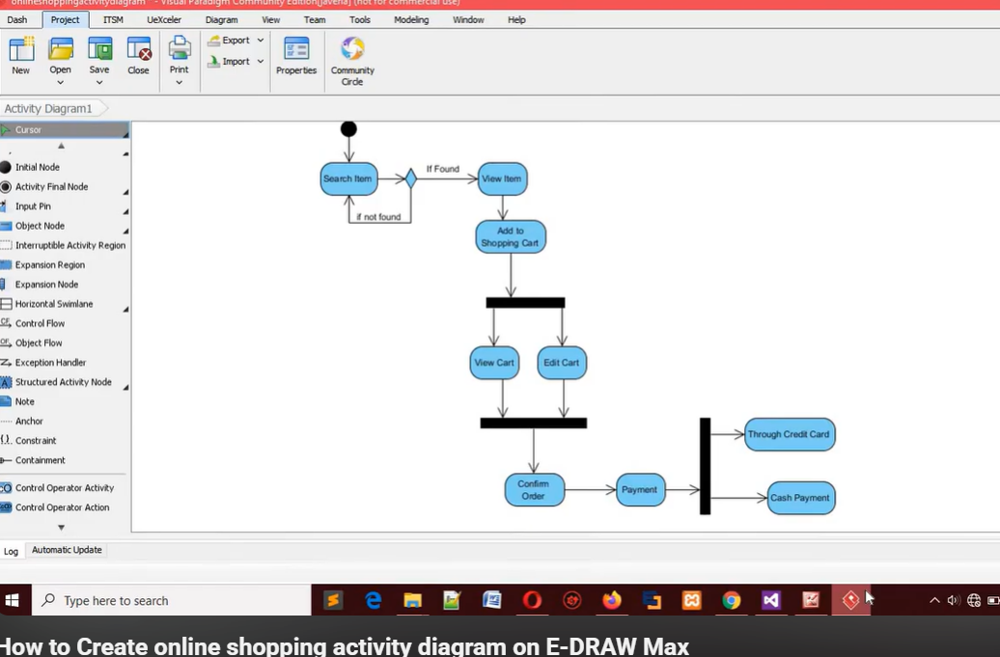

Figure 67: How to make activity diagram.

Even though the process had its difficulties, I remained focused on producing a report that was accurate, well-structured, and aligned with the technical work I completed. I made sure that every section was formatted clearly and supported with the right diagrams and explanations. The entire experience taught me that steady effort and a willingness to learn can lead to a strong outcome. This report not only explains the technical side of my system but also reflects the growth, consistency, and dedication I applied throughout the project.

## Findings and Process

The development and implementation of the Survey Equipment Rental platform produced several meaningful outcomes that reflected both technical success and practical value. These results were seen across different areas such as equipment listing, booking process, security, system responsiveness, and user engagement. One of the most noticeable achievements was the smooth transition from traditional manual equipment rental methods to a fully digital, organized, and accessible platform. The platform made it easier for users to view real-time availability, book tools quickly, and receive confirmations without needing to physically visit or call rental providers. This shift brought major improvements in convenience and time-saving for users, especially small businesses and independent surveyors.

The system development process followed an iterative approach where each feature was carefully built and improved through feedback and testing. Several important elements were considered:

* The flexibility of the platform during development allowed changes and adjustments based on what users needed most.
* Core subsystems such as user registration, profile management, equipment listing, cart system, and booking functionality worked effectively and supported overall system performance.
* The platform’s focus on digital accessibility matched the expectations of users and fulfilled the goal of providing a centralized rental system.
* Secure login, role-based access control, and payment integration gave users confidence while interacting with the platform.
* Real-time notifications and updates about bookings helped maintain communication and trust between users and the system.

The Survey Equipment Rental system has shown strong potential in changing how survey tools are accessed in Nepal. With its easy-to-use features, automated rental flow, and secure processes, it has created a better experience for users who previously faced difficulties with unreliable availability and unclear rental procedures. The platform not only improves how the rental process works, but also introduces a digital method that meets industry needs. It offers a foundation that can grow further and make an even greater impact on the survey equipment rental market in the future.

## System Evaluation

The Survey Equipment Rental system was evaluated based on its functionality, ease of use, and relevance to the actual rental market in Nepal. The system not only meets technical requirements but also introduces operational improvements that were not available in traditional rental methods.

* Operational Impact

The move from calling rental shops to using a website for bookings has made a huge difference. Now, users can search, filter, and rent equipment online without visiting shops or waiting for replies. This convenience helps users save time and effort, which is especially valuable during urgent project deadlines.

* Market Impact and Business Prospects

The system brings new standards for survey equipment rentals in Nepal. It offers a business opportunity to suppliers as well, allowing them to list products and manage bookings digitally. In a growing market like Nepal where infrastructure projects are increasing, such a platform can play an important role in making tools more accessible. The system can also be extended with features like surveyor hiring or equipment sales to grow its user base further.

## Project Planning & Resources

The planning and management of this project gave me a lot of insight into what works well and what needs more attention in a full-stack development workflow. At the start, I put a lot of effort into designing the artefacts and diagrams, which was necessary, but it slightly shifted my focus away from beginning the practical coding work early. As a result, I had less time for detailed testing and feature refinement later in the process. Although the final system functioned as expected, I now understand that keeping a better balance between planning and development would have helped improve the overall project flow. If I had spaced out tasks more evenly, I could have introduced extra enhancements or tested for more edge cases.

To stay organized during development, I followed the Scrum methodology. I divided the entire system into small, manageable tasks and focused on them sprint by sprint. Each sprint was used to build or fix a specific part of the platform—like user authentication, booking logic, or notification handling. I used ClickUp to manage tasks, track daily goals, and monitor deadlines. This method helped me adjust quickly whenever priorities changed or when feedback pointed out areas needing improvement.

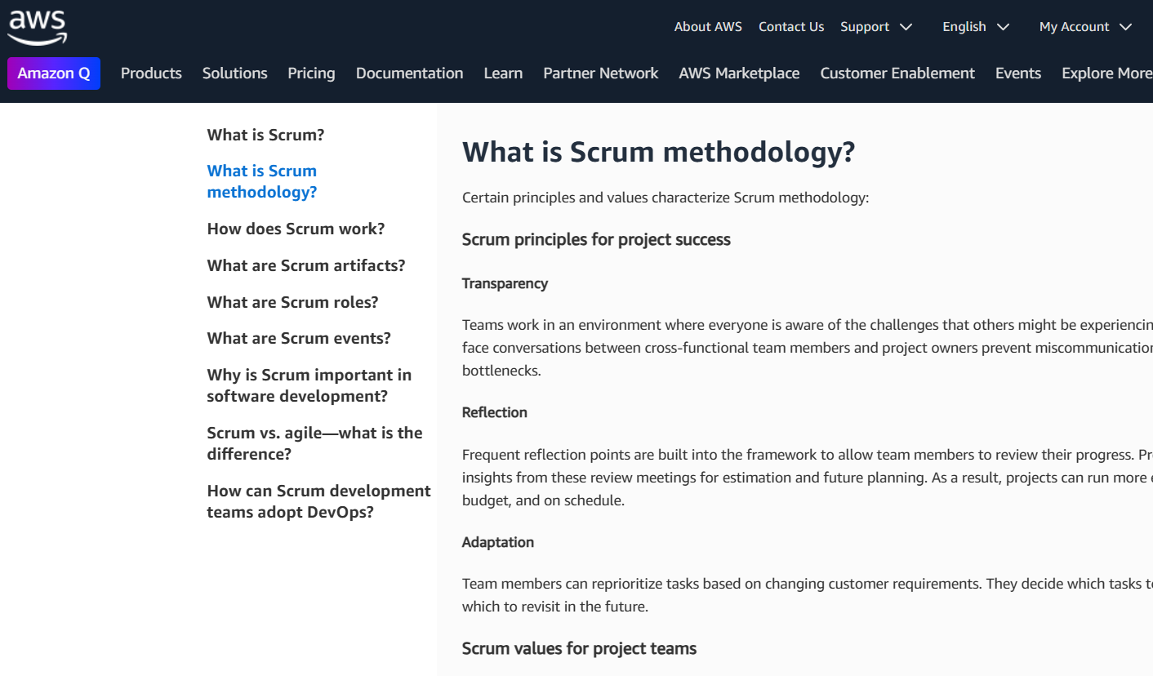

Figure 68: Understanding Scrum in depth.

In terms of technical resources, I heavily relied on official documentation from the tools and libraries I used. React docs guided me while building the frontend structure, and Node.js with Express documentation helped a lot while handling routes and middleware. For database management, MongoDB’s resources were easy to follow, especially when working with dynamic data structures. Whenever I faced issues, I turned to platforms like Stack Overflow, which provided a lot of real-world solutions shared by experienced developers. This kind of support played a key role in solving unexpected problems without delay.

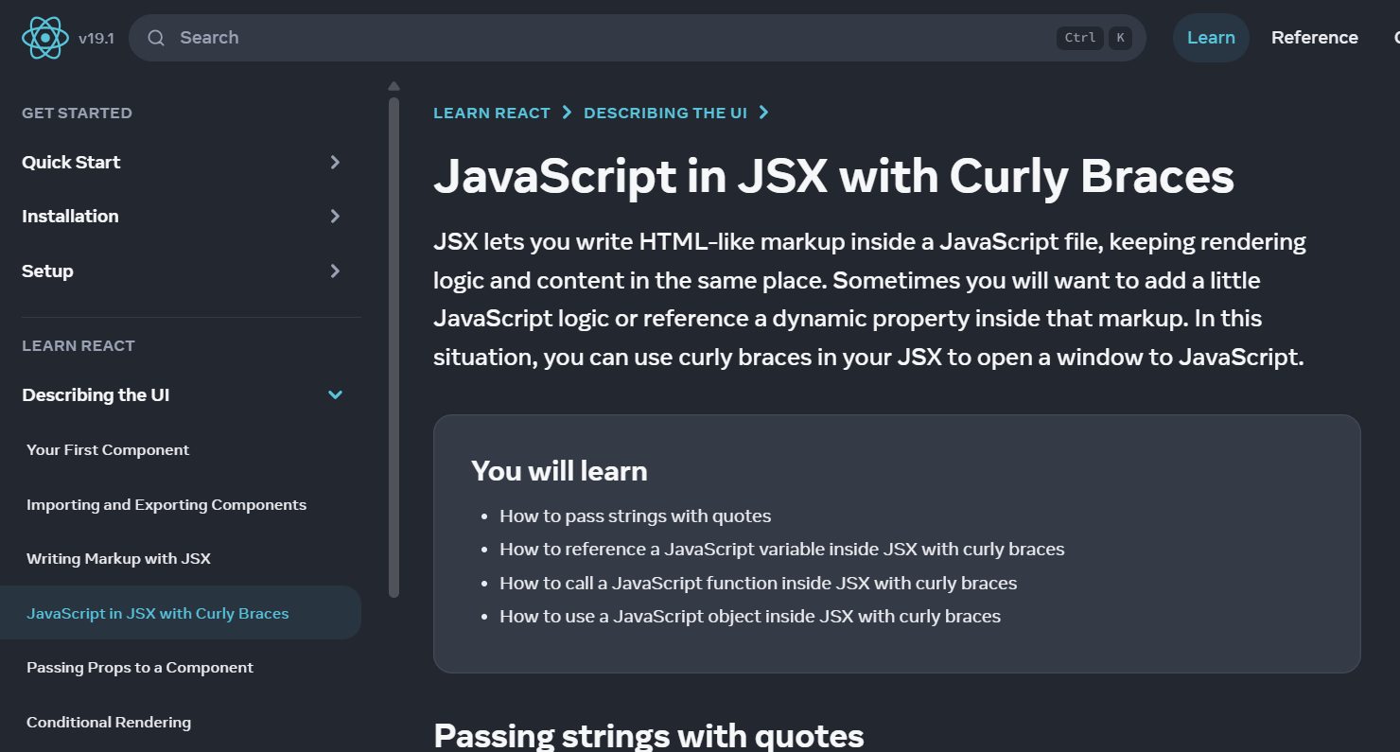

Figure 69:React documentation

While testing the Khalti payment system, I used the official demo account to explore how the transaction process works from start to finish. Their documentation provided clear examples, which helped me understand how to send payment requests, handle responses, and prepare the required backend routes. Some configuration steps took extra effort to troubleshoot, but this gave me a better grasp of how real payment systems behave during integration. On a similar note, I reviewed Leaflet as a possible solution for displaying pickup or drop-off locations using maps. Although it wasn’t added in the current version due to time constraints, the documentation was easy to follow and helped me plan how such features could be developed later to enhance the platform's usability.

## Self-Reflection

Working on this project has taught me a lot, both in terms of technical skills and how to manage my time and responsibilities better. At the beginning, I had a basic understanding of how web systems are built, but I wasn’t confident in handling the complete process myself. By building this platform from scratch, I learned how to connect the frontend with the backend, organize data using MongoDB, and create a smooth user experience through a clean interface. Figuring out how to implement login systems, secure user data, and manage bookings helped me understand what it really takes to make a working product, not just write code that runs.

One of the biggest lessons I learned was how important planning is. Even though I had limited time after artefact submission, following a step-by-step process and focusing on one feature at a time helped me avoid getting overwhelmed. I used tools like ClickUp to stay on track with tasks and GitHub to keep my code organized. Whenever I ran into errors, I learned how to troubleshoot more efficiently by checking documentation or asking for help online. These small but consistent efforts taught me to stay patient and not give up easily when things didn’t work.

More than anything, this project gave me the confidence to believe that I can take an idea and turn it into something real. It showed me that even if the start is rough or unexpected problems come up, staying focused and learning through the process really pays off. I now feel more prepared to take on new challenges, whether it’s in further studies, job opportunities, or future projects I might build on my own.

# **Evidence of Project Management**

## Log Sheet



Figure 70: Log Sheet-1



Figure 71 : Log Sheet -2



Figure 72: LogSheet-3



Figure 73: Log Sheet-4

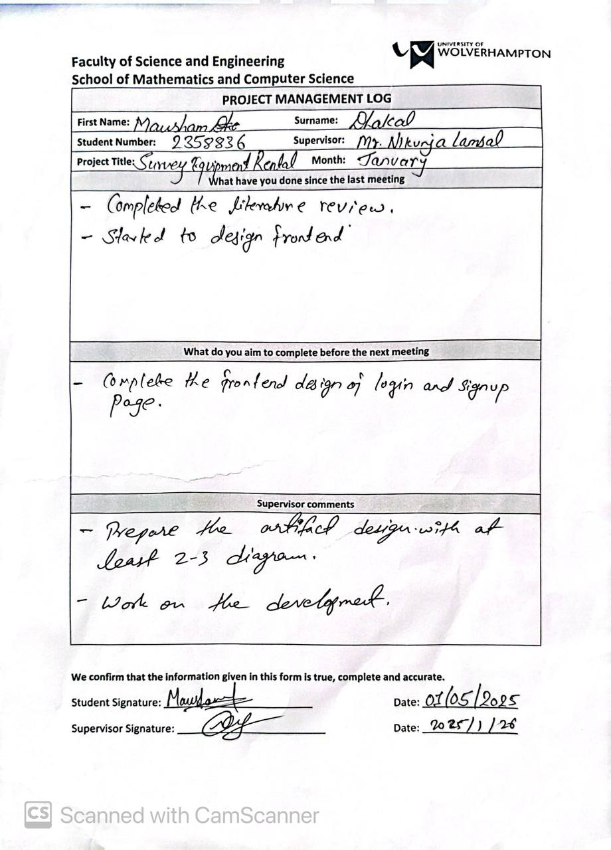

Figure 74: Log Sheet-5

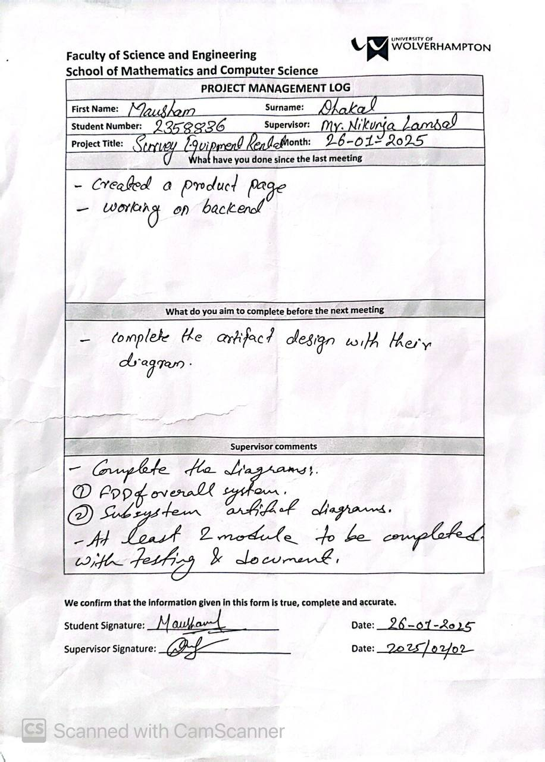

Figure 75: Log Sheet-6

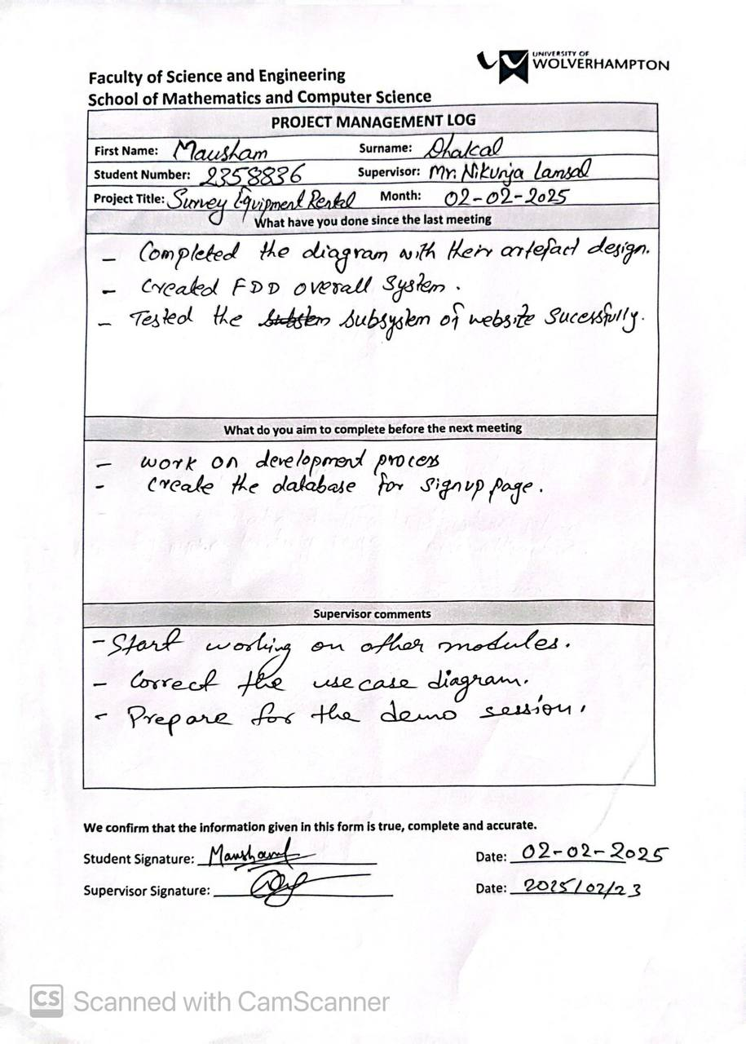

Figure 76: Log Sheet-7

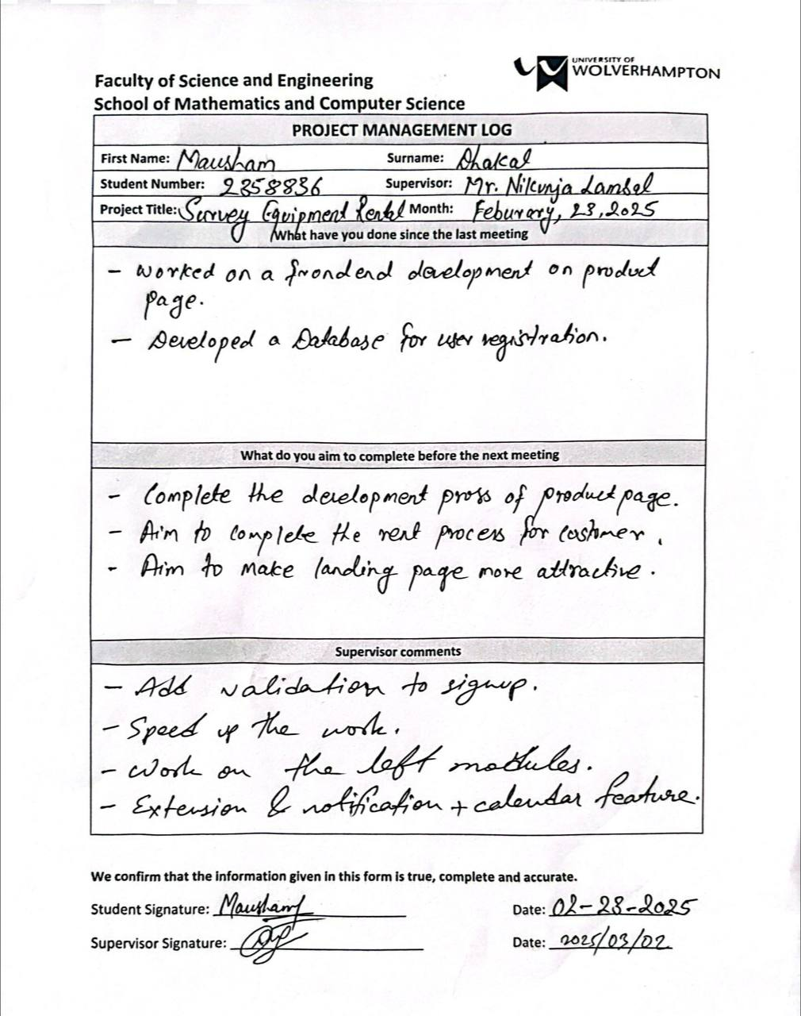

Figure 77: Log Sheet-8

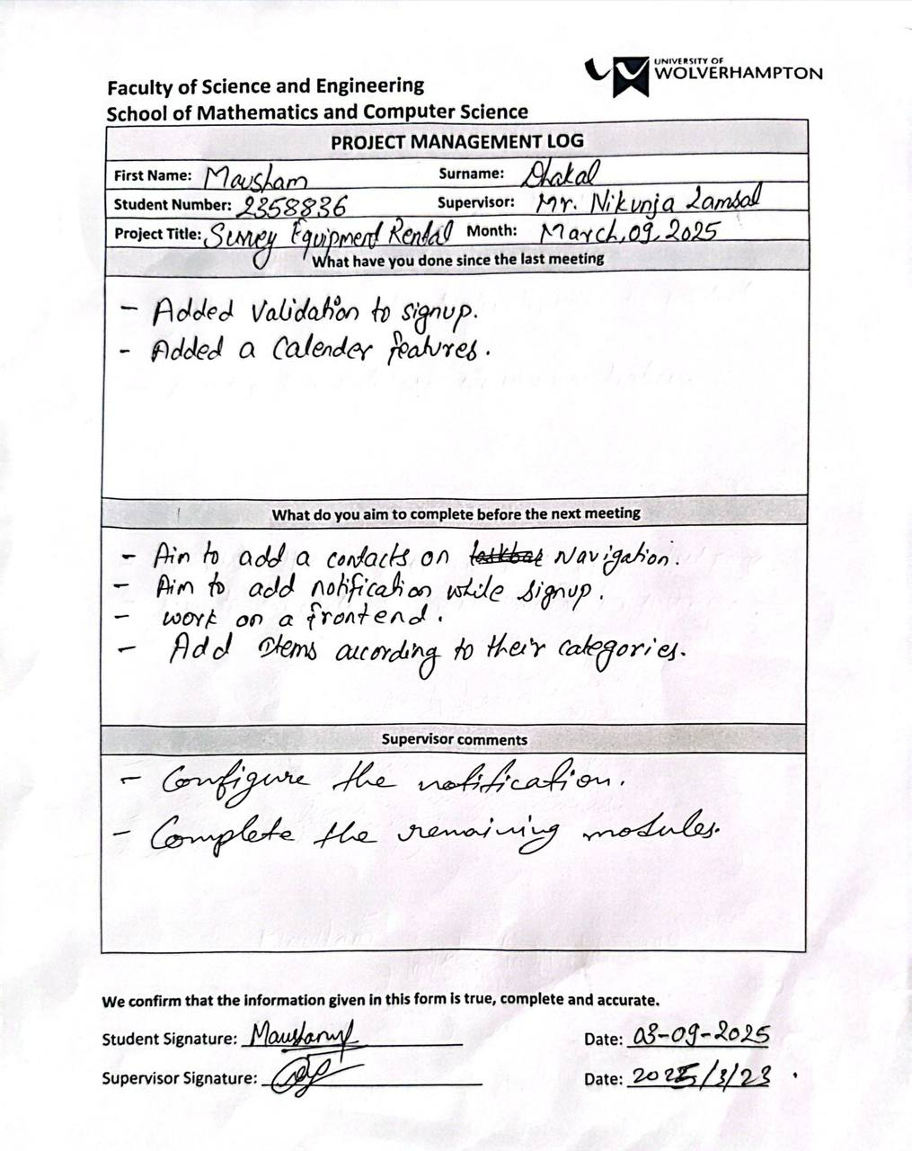

Figure 78: Log Sheet-9

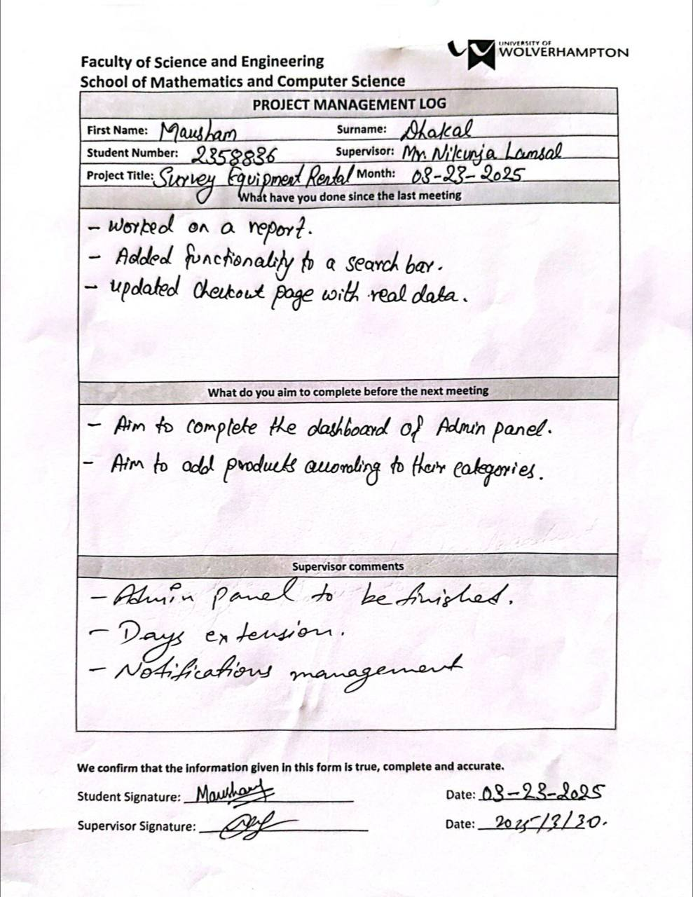

Figure 79: Log Sheet-10

## Gantt Chart

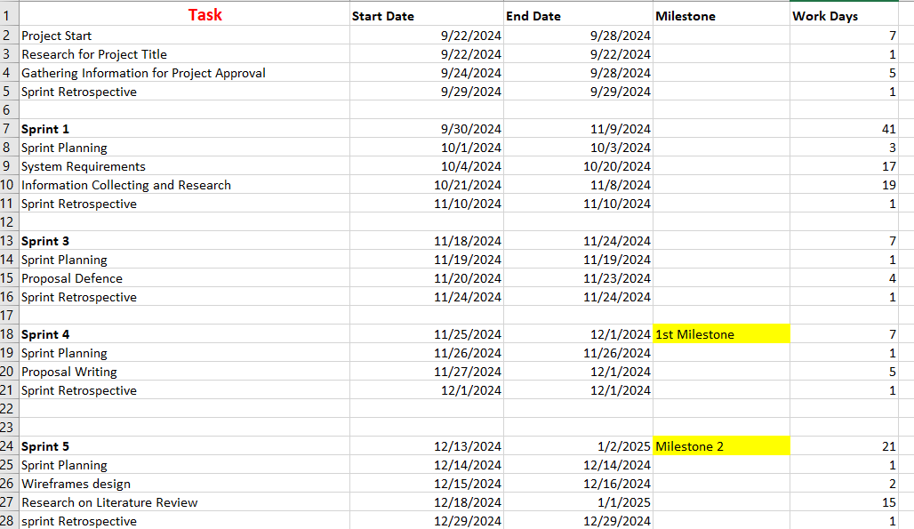

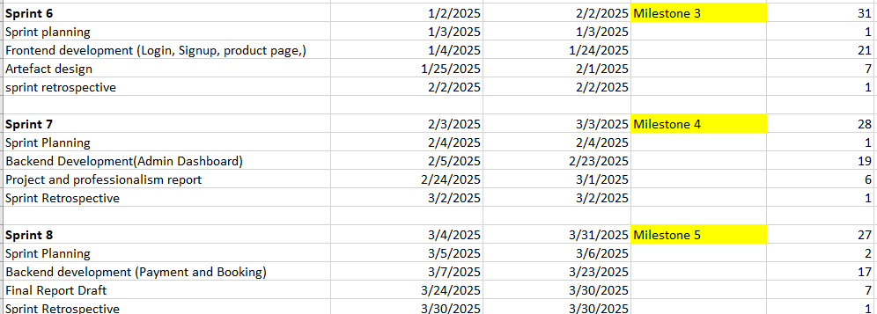

Figure 80:Gantt Chart

# **References**

Angel Alejandro Juan, C. A. M. J. F. J. D. A., 28 January 2016. Electric vehicles in logistics and transportation: A survey on emerging environmental, strategic, and operational challenges. *Energies,* 9(2).

Ankita Chawla, A. S. P. P. H. Y. N. M., 20 April 2021 . Transportation and Logistic e-commerce Solutions. 7(2), p. 9.

Anton Jansson, J. S., 22. Exploring Servitization in the Construction Industry: A Qualitative Case Study of a Swedish Rental. p. 56.

Anuj Pal Kapoor, M. V., May 2021. Want it, Rent it: Exploring Attributes Leading to Conversion for Online Furniture Rental Platforms. 16(2), p. 19.

Bajwa, R., 2021. *Buying vs. leasing equipment: Which one is better?.* [Online]   
Available at: https://eiexchange.com/content/buying-vs-leasing-equipment-which-one-is-better

Basnet, Y., n.d. *Asian Techno Traders.* [Online]   
Available at: https://www.attnepal.com/  
[Accessed 18 Feburary 2025].

Chukurna, O. T. T. C. M. N. V. P. L. &. K. V., 2024. Transformation of E-Commerce Business Models in the Digital Economy. *Naukovyi Visnyk Natsionalnoho Hirnychoho Universytetu,* Issue 5.

Costamagna, A. M. &. M., 2023. Environmental assessment of the rental business model: a case study for formal wear. *Environment, Development and Sustainability,* 25(8), p. 19.

Creation, D., n.d. *surveyingconcern.* [Online]   
Available at: https://www.surveyingconcern.com.np/  
[Accessed 20 02 2025].

Grigorios D. Konstantakopoulos, S. P. G. a. E. P. K., July 2022. Vehicle Routing Problem and Related Algorithms for Logistics Distribution: A Literature Review and Classification. 22(3), p. 29.

Lindsay McCoy, T. C., 2022. Collaborative Consumption: A Study of Sustainability Presentation in Fashion Rental Platforms. *Sustainability,* 14(14), p. 25.

Liwei Li, W. W., 2020. The effects of online trust-building mechanisms on trust in the sharing economy: The perspective of providers. *Sustainability,* 12(5), p. 14.

Mitchell Watt, H. W., August 2018. Trust Mechanisms and Online Platforms: A Regulatory Response. Issue 97, p. 83.

Nandi, P., 2025. *Rental Equipment Market Size, Growth, Trends, Report 2032,* Pune, India: Market Research Future.

Padmanaban G, A. P., 9 Jan 2025. Analysis of Renting Versus Buying Construction Heavy Equipment. Issue November 15, 2024, p. 27.

Santhoskumar A, M. V. M. M., April 2024 . A Study On Customer Preference Towards Car/Bike Rental Services With Special Reference To Coimbatore City. 12(4).

S, B., 2025. *nimblework.* [Online]   
Available at: https://www.nimblework.com/agile/scrum-methodology/  
[Accessed 27 March 2025].

Stacy H.N. Lee, P.-S. C., 2020. Investigating consumer attitudes and intentions toward online fashion renting. *Investigating consumer attitudes and intentions toward online fashion renting,* January, 52(101892), p. 12.

System, O. M., n.d. *office material system.* [Online]   
Available at: https://www.officematerialsnepal.com/  
[Accessed 18 02 2025].

# **Appendices**